A

Project Report

on

**SUPER RESOLUTION ENHANCEMENT WITH CONVOLUTIONAL NEURAL NETWORK AND GENERATIVE ADVERSAL NETWORK** Submitted in partial fulfillment of the requirements for the award of the degree of Bachelor of Technology

by

**Jagannath Rao Are**

**(20EG105456)**



Under the guidance of

**B. Ravinder Reddy**

Assistant Professor,

Department of CSE

**DEPARTMENT OF COMPUTER SCIENCE AND ENGINEERING**

**ANURAG UNIVERSITY**

**VENTAKAPUR (V), GHATKESAR (M), MEDCHAL (D), T.S - 500088**

**TELANGANA**

**(2023-2024)**

**DECLARATION**

I hereby declare that the report entitled **“****Super Resolution Enhancement With Convolutional Neural Network and Generative Adversal Network”** submitted to the **Anurag University** in partial fulfillment of the requirements for the award of the degree of **Bachelor of Technology (B. Tech)** in **Computer Science and Engineering** is a record of an original work done by me under the guidance of **B. Ravinder Reddy, Assistant Professor** and this report has not been submitted to any other university for the award of any other degree or diploma.

Place: Anurag University, Hyderabad Jagannath Rao Are

(20EG105456)



**CERTIFICATE**

This is to certify that the project report entitled **“Super Resolution Enhancement With Convolutional Neural Network and Generative Adversal Network”** being submitted by **Jagannath Rao Are** bearing the Hall Ticket numbers **20EG105456** respectively in partial fulfillment of the requirements for the award of the degree of the **Bachelor of Technology** in **Computer Science and Engineering** to **Anurag University** is a record of bonafide work carried out by her under my guidance and supervision for the academin year 2023 to 2024.

The results presented in this report have been verified and found to be satisfactory. The results embodied in this report have not been submitted to any other University for the award of any other degree or diploma.

|  |  |
| --- | --- |
| Signature of The Supervisor  B. Ravinder Reddy  Assistant Professor  Department of CSE | Signature Dean,  Dr. G. Vishnu Murthy  Department of CSE |

External Examiner

**ACKNOWLEDGMENT**

I would like to express our sincere thanks and deep sense of gratitude to project supervisor **B. RAVINDER REDDY,** Assistant Professor, Department of Computer Science and Engineering, Anurag University for his constant encouragement and inspiring guidance without which this project could not have been completed. His critical reviews and constructive comments improved my grasp of the subject and steered to the fruitful completion of the work. His patience, guidance and encouragement made this project possible.

I would like to acknowledge my sincere gratitude for the support extended by **DR. G. VISHNU MURTHY**, Dean, Department of Computer Science and Engineering, Anurag University. I also express my deep sense of gratitude to **Dr. V. V. S. S. S. BALARAM**, Academic coordinator. **Dr. PALLAM RAVI**, Project Coordinator and project review committee members, whose research expertise and commitment to the highest standards continuously motivated me during the crucial stages of my project work.

I would like to express my special thanks to **Dr. V. VIJAYA KUMAR,** Dean School of Engineering, Anurag University, for their encouragement and timely support in my B. Tech program.

Jagannath Rao Are

(20EG105456)

**ABSTRACT**

This Project discusses super-resolution using Generative adversarial networks and compares it with CNN-based and mathematical interpolation. The aim is to produce high-quality images from low-quality input images with dimension upscaling. VGG19 is used to measure the loss which proved to be better than MSE. Convolution neural networks (CNN) were the traditional model for enhancing image resolution. Over the past few years, GAN’s achieved a better Mean-Opinion-Score than CNN in producing high-quality images. The last model is known as enhanced Super Resolution GAN (ESR-GAN) which made significant improvements for SR-GAN. The ESR-GAN is widely used in game development and movie remastering. The project aiming to elevate the quality of low-resolution images by upscaling their dimensions while preserving or even enhancing image details. Employing Generative Adversarial Networks (GANs), Convolutional Neural Networks (CNNs), and mathematical interpolation techniques, the study scrutinizes the efficacy of each approach. Notably, the evaluation metric shifts from conventional Mean Squared Error (MSE) to utilizing VGG19, a pre-trained deep CNN, for loss measurement, proving more effective. While CNNs have been the traditional choice for image enhancement, recent years have witnessed the ascendancy of GANs, particularly in producing visually superior images, as indicated by higher Mean Opinion Scores (MOS). The project culminates with the exploration of the Enhanced Super Resolution GAN (ESR-GAN), showcasing significant advancements over its predecessors and finding versatile applications in gaming and movie industries for immersive experiences and remastering endeavors, respectively. This comprehensive analysis underscores the pivotal role of GANs, epitomized by the ESR-GAN model, in the domain of image super-resolution, heralding a new era of enhanced visual content across various domains.

Keywords: Convolutional Neural Network, Super-Resolution Convolutional Neural Network, Generative Adversarial Network, Super-Resolution Generative Adversarial Network, Peak Signal-to-Noise Ratio, Mean Squared Error, Structural Similarity Index.

**TABLE OF CONTENT**

|  |  |  |
| --- | --- | --- |
| **S. No.** | **CONTENT** | **Page No.** |
| 1. | Introduction   * 1. Motivation   2. Problem Definition   3. Problem Illustration   4. Objective of the project   5. Introduction to the topics   1.5.1 CNN  1.5.2.SRCNN  1.5.3.GAN  1.5.4.SRGAN | 1  2  2  3  5  6  6  8  9  11 |
| 2. | Literature Document | 13 |
| 3. | Proposed Method  3.1. Fine-tuning the model  3.2. Generating summaries using fine-tuned model  3.3. Illustration- Map Reduce Paradigm | 25  26  27  28 |
| 4. | Implementation  4.1. Functionalities  4.1.1 Data preparation  4.1.2.Model Development  4.1.3 Training  4.1.4.Evaluation  4.2 Attributes  4.3.Experiment screenshots  4.4.Dataset  4.5.Proposed Method | 30  30  30  31  32  33  33  34  38  41 |
| 5. | Experimental Setup  5.1. Install Python IDLE-3.11.4  5.2. Connect with Command Prompt  5.3. HTML  5.4. CSS  5.5 Java script  5.6.Flask  5.7.Libraries Used  5.7.1.Numpy  5.7.2.Matplotlib  5.7.3.SYS  5.7.4.Keras  5.7.5.Skimage  5.7.6.CV2  5.7.7.OS  5.7.8.Pickle  5.7.9.Streamlit  5.8.Parameters  5.8.1.PSNR  5.8.2.MSE  5.8.3.SSIM | 43  43  43  44  46  48  50  52  52  54  55  56  58  60  61  63  65  67  67  68  69 |
| 6. | Discussion of Results | 71 |
| 7.  8. | Conclusion  References | 73  74 |
|  |  |  |
|  |  |  |

**List of Figures**

|  |  |  |
| --- | --- | --- |
| **Figure No** | **Figure Name** | **Page No** |
| 4.3.1 | Website using flask framework | 29 |
| 4.3.2 | Website for improving image | 30 |
| 4.3.3 | Enhanced output of image | 30 |
| 4.3.4 | Website for improving image | 31 |
| 4.3.5 | Enhanced output of image | 31 |
| 4.3.6 | Improving images of animals | 32 |
| 4.3.7 | Enhanced output of image | 32 |
| 4.4.1 | Dataset of original images | 33 |
| 4.4.2 | Dataset of original images | 33 |
| 4.4.3 | Dataset of animals, rocks, sea water etc. | 34 |
| 4.4.4 | Dataset of animals | 34 |
| 4.4.5 | Dataset of living and non-living things | 35 |
| 4.4.6 | Dataset of eatables | 35 |
| 4.4.7 | Dataset of expressions of people | 36 |
| 4.5.1 | Overview of super-resolution process | 37 |
| 5.1.1 | Python IDLE | 38 |
| 5.2.1 | Command Prompt | 39 |
| 5.3.1 | Source code of HTML | 40 |
| 5.5.1 | Source code of Java Script | 41 |
| 5.6.1 | Web application using flask | 42 |



|  |  |  |
| --- | --- | --- |
| **Table No** | **Table Name** | **Page No** |
| 2.1 | Comparison of Existing Methods | 20 |

**List of Abbreviations**

|  |  |
| --- | --- |
| **Abbreviations** | **Full Form** |
| GAN | Generative Adversarial Network |
| CNN | Convolutional Neural Network |
| SRCNN | Super-Resolution Convolutional Neural Network. |
| SRGAN | Super-Resolution Generative Adversarial Network |
| PSNR | Peak Signal-to-Noise Ratio |
| MSE | Mean Squared Error |
| SSIM | Structural Similarity Index Measure |

**1. Introduction**

Everyone has a lot of memories that are saved in photos. However, these photos are not of good resolution. It cannot be shown in a large screen and there are many missing details. Hence, there is a “remastering” technique that attempts to recover most details possible from low-quality photos. Besides, it scales up the image for higher dimensions with the most enhancement. The Generative Adversarial Network (GAN) has been used to improve these tasks like in [1, 2, 3]. Our project is based on [3]. The GAN network’s main objective is to generate the most realistic fake images. Hence, it can generate a super-resolution image that, theoretically, should not be detectable that it was a generated image. There are different approaches for achieving the same task such as bicubic interpolation [4]. This paper covers the architecture of GAN, conditional GAN, and SR-GAN. Besides, it gives a literature review of the GAN and different designed architectures for super-resolution tasks. Vanilla Architecture The generative adversarial network is a deep learning model inclusively contains two networks. Introduced by Ian et al in 2014 [5] The First one is the generative network amd the discriminative network is has a different objective. The generative network tries to create an output that is looks undistinguishably like the real data. The Discriminator tries to distinguish between a fake image and a real image. Usually, and in our case, the discriminator and the generator are trained simultaneously versus each other in each batch in each epoch. This training between them is adversarial from the bird eye view. Furthermore, their objectives go against each other. However, from a closer look it can be viewed as a very cooperative view [6]. Moreover, each time the generator is detected as fake it improves itself, hence, giving better results based on the discriminator feedback. On the other hand, the discriminator gets stronger when it is deceived by the generator which results in a better judge for the generator. Once, the training is over the discriminator network is taken away and the generator network is used to generate new examples. The generative adversarial network should have an input of random noise. However, this is not the case with the super-resolution task. Formula one defines the GAN training with its objective function

**1.1 Motivation**

The motivation behind this project stems from the ever-growing demand for high-quality images in various domains such as computer vision, medical imaging, satellite imaging, and entertainment industries like gaming and movie production. Despite advances in imaging technology, low-resolution images remain a prevalent issue due to constraints in hardware, transmission, or storage. Enhancing the resolution of such images while preserving or improving their quality is thus a crucial endeavor with widespread implications.

Traditionally, Convolutional Neural Networks (CNNs) have been employed for image super-resolution tasks. However, with the emergence of Generative Adversarial Networks (GANs), there has been a paradigm shift towards more advanced and effective methods of generating high-quality images. The allure of GANs lies in their ability to generate realistic images that are indistinguishable from genuine high-resolution images.

The motivation to compare CNNs and GANs for image super-resolution arises from the need to understand the strengths and weaknesses of each approach. By evaluating their performance using metrics such as Mean Opinion Score (MOS), researchers can identify the most suitable method for specific applications.

**1.2 Problem Definition**

The problem at the heart of this project revolves around the enhancement of low-resolution images to high-resolution counterparts while preserving or improving their visual quality. This task, known as image super-resolution, is pivotal across numerous domains where high-fidelity images are imperative despite limitations in hardware or data transmission capabilities. The project's primary objective lies in exploring and comparing various methodologies for image super-resolution, including Convolutional Neural Networks (CNNs), Generative Adversarial Networks (GANs), and mathematical interpolation techniques. Additionally, the project aims to evaluate the efficacy of employing VGG19, a pre-trained deep convolutional neural network, for measuring loss in image super-resolution tasks. By assessing the performance of both traditional CNN-based approaches and emerging GAN-based methods using metrics like Mean Opinion Score (MOS), the project seeks to uncover insights into the most effective techniques for achieving high-quality image enhancement. Moreover, the investigation delves into the Enhanced Super Resolution GAN (ESR-GAN) model, scrutinizing its advancements over conventional SR-GAN and other super-resolution techniques. Through these endeavors, the project endeavors to shed light on practical applications of image super-resolution, spanning fields such as gaming, movie remastering, medical imaging, and satellite imaging, thereby contributing to the continual advancement of image processing technologies. The project's core objective is to scrutinize and compare diverse methodologies for image super-resolution. Convolutional Neural Networks (CNNs), long-standing stalwarts of image processing, are juxtaposed with the emergent Generative Adversarial Networks (GANs) and traditional mathematical interpolation techniques. These methods form the triad of investigation, each offering unique advantages and challenges. Moreover, the project seeks to refine the evaluation process by leveraging VGG19, a pre-trained deep CNN, to measure loss in image super-resolution tasks, thereby providing a more perceptually meaningful assessment. Through quantitative metrics like Mean Opinion Score (MOS) and qualitative evaluations, the project endeavors to discern the efficacy of CNN-based and GAN-based approaches. Delving further, the study explores the Enhanced Super Resolution GAN (ESR-GAN), a cutting-edge advancement in GAN-based super-resolution techniques, showcasing its potential across various applications. By unraveling the intricacies of these methodologies, the project aims to contribute valuable insights into the optimal strategies for achieving high-quality image enhancement in diverse real-world scenarios.

**1.3 Problem Illustration**

To illustrate the problem of enhancing low-resolution images, consider a scenario in medical imaging where MRI scans are utilized for diagnosing conditions. Due to factors like scanning time constraints or hardware limitations, the obtained MRI images may have lower resolution than desired, compromising the clarity of anatomical structures and potentially affecting diagnostic accuracy.

In this scenario, image super-resolution techniques become crucial for enhancing the quality of low-resolution MRI scans. Traditional methods like mathematical interpolation may provide a quick solution but often fail to preserve fine details and produce visually plausible results.

Convolutional Neural Networks (CNNs) offer a more sophisticated approach by learning complex mappings between low-resolution and high-resolution image pairs. By training on a dataset of paired images, CNNs can effectively reconstruct missing details in low-resolution MRI scans, resulting in enhanced images that better represent the underlying anatomical structures.

Alternatively, Generative Adversarial Networks (GANs) introduce a novel paradigm for image super-resolution. In a GAN framework, a generator network learns to produce high-resolution images from low-resolution inputs, while a discriminator network evaluates the realism of the generated images. Through adversarial training, GANs can generate visually convincing high-resolution MRI scans that closely resemble real images.

To further illustrate the problem, imagine comparing the results obtained from CNN-based and GAN-based approaches. While CNNs may excel at preserving fine details and structural accuracy, GANs may produce images with enhanced texture and realism. Evaluating the performance of each approach using metrics like Mean Opinion Score (MOS) can provide insights into their respective strengths and limitations.

advancements like the Enhanced Super Resolution GAN (ESR-GAN) introduce additional complexity to the problem. ESR-GANs leverage innovative architectures and training strategies to achieve even higher levels of image fidelity and detail preservation, making them particularly suited for demanding applications like medical imaging

Imagine a scenario in satellite imaging where low-resolution satellite imagery is acquired for monitoring environmental changes, urban planning, or disaster response. These low-resolution images may lack the necessary detail to accurately identify objects or changes on the ground, hindering decision-making processes.

image super-resolution techniques become essential for enhancing the quality of satellite imagery. Traditional methods like interpolation may struggle to produce sharp, high-resolution images, leading to inaccuracies in analysis and decision-making.

Convolutional Neural Networks (CNNs) offer a powerful solution by learning complex patterns and structures in the low-resolution satellite imagery. By training on a dataset of paired images, CNNs can learn to generate high-resolution images that capture finer details and nuances, improving the overall quality of the satellite data.

Generative Adversarial Networks (GANs) provide a novel approach to image super-resolution in satellite imaging. GANs can generate realistic high-resolution images from low-resolution inputs by leveraging a generator-discriminator architecture. This enables the production of visually convincing satellite imagery with enhanced clarity and detail, facilitating more accurate analysis and interpretation.

**1.4. Objective of the Project**

The objective of the project is to comprehensively investigate and compare different methodologies for enhancing the resolution of low-quality images, a process known as image super-resolution. The project aims to delve into a range of techniques, including Convolutional Neural Networks (CNNs), Generative Adversarial Networks (GANs), and traditional interpolation methods, to understand their effectiveness in producing high-quality, visually appealing images. Through a meticulous analysis of performance metrics such as Mean Squared Error (MSE), Peak Signal-to-Noise Ratio (PSNR), Structural Similarity Index (SSIM), and potentially subjective metrics like Mean Opinion Score (MOS), the project seeks to gauge the quality and fidelity of super-resolved images generated by each technique. By conducting a comparative analysis, the project aims to elucidate the strengths and weaknesses of CNN-based, GAN-based, and traditional interpolation approaches, considering factors like computational efficiency, preservation of fine details, and suitability for various applications. Additionally, the project explores advanced techniques like the Enhanced Super Resolution GAN (ESR-GAN) and examines their potential to further improve the quality of super-resolved images. Through practical applications spanning medical imaging, satellite imaging, surveillance systems, gaming, and movie production, the project aims to demonstrate the real-world relevance and impact of image super-resolution techniques. Ultimately, the project aims to provide recommendations for selecting appropriate techniques based on specific application requirements and to suggest future research directions for advancing the field of image super-resolution.

**1.5 Introduction to the Topics**

**1.5.1 Convolutional Neural Networks:**

Convolutional Neural Networks (CNNs) represent a cornerstone in the realm of deep learning, specifically tailored to process and analyze visual data, such as images and videos. CNNs are structured in a hierarchical manner, consisting of multiple layers that specialize in feature extraction and hierarchical abstraction. At the core of CNN architecture lie convolutional layers, where filters are applied across the input image to extract meaningful features, capturing patterns like edges, textures, and shapes. Subsequent layers, typically pooling layers, serve to downsample the feature maps, reducing spatial dimensions while retaining essential information. Activation functions, such as the Rectified Linear Unit (ReLU), introduce non-linearity to the network, enabling it to model complex relationships within the data. Through iterative training with backpropagation, CNNs adjust their parameters to minimize a defined loss function, thus learning to accurately classify or predict outcomes. Transfer learning, a technique leveraging pre-trained CNN models on large datasets like ImageNet, facilitates the adaptation of these networks to new tasks with smaller datasets, expediting training and enhancing performance. CNNs have not only revolutionized image processing tasks like classification and segmentation but also demonstrated efficacy in tasks like image super-resolution, leveraging their capacity to learn intricate features from raw visual data, thereby solidifying their status as a cornerstone technology in modern artificial intelligence applications. At the heart of CNNs are convolutional layers, which apply filters to input images, detecting various features such as edges, textures, and shapes. Through the use of multiple convolutional layers, CNNs can progressively learn increasingly complex and abstract features, capturing intricate patterns present in the data.

Pooling layers further enhance the CNN architecture by downsampling feature maps, reducing computational complexity while retaining important spatial information. This hierarchical feature extraction process enables CNNs to effectively learn discriminative representations of input images, essential for tasks like image classification, object detection, and image super-resolution.

In addition to their applications in traditional supervised learning tasks, CNNs have also demonstrated remarkable capabilities in unsupervised and semi-supervised learning scenarios. Unsupervised pre-training techniques, such as autoencoders and generative adversarial networks (GANs), enable CNNs to learn rich representations of data without requiring labeled examples, thereby facilitating transfer learning and improving performance on downstream tasks with limited labeled data. Semi-supervised learning approaches leverage both labeled and unlabeled data to train CNNs, effectively utilizing the abundance of unlabeled data available in many real-world scenarios to enhance model generalization and performance.

Moreover, the interpretability of CNNs has been a subject of extensive research and development. Techniques such as gradient-based visualization methods, layer-wise relevance propagation (LRP), and attention mechanisms provide insights into the decision-making process of CNNs, allowing researchers and practitioners to understand how the network arrives at its predictions and to diagnose potential biases or errors.

Furthermore, the deployment of CNNs in resource-constrained environments, such as mobile devices and embedded systems, has been made possible through model compression techniques like pruning, quantization, and knowledge distillation. These methods reduce the computational and memory requirements of CNN models without significantly compromising their performance, enabling the deployment of deep learning solutions on edge devices with limited resources.

The synergy between CNNs and other machine learning techniques, such as recurrent neural networks (RNNs) and graph neural networks (GNNs), has led to the development of hybrid architectures capable of handling diverse types of data and tasks. For example, CNN-RNN hybrids, known as convolutional recurrent neural networks (CRNNs), are well-suited for tasks involving sequential data, such as video captioning and speech recognition, by combining the spatial hierarchy captured by CNNs with the temporal dependencies modeled by RNNs.

Looking ahead, the evolution of CNNs is expected to continue, driven by advancements in hardware acceleration, algorithmic innovation, and the availability of large-scale datasets. As CNNs become more efficient, flexible, and interpretable, they will continue to play a central role in shaping the future of artificial intelligence and revolutionizing industries across the globe.

**1.5.2 Super-Resolution Concolutional Neural Networks:**

SRCNN's success has spurred further advancements in the field of single-image super-resolution (SISR), with researchers proposing various extensions and improvements to the original architecture. One notable development is the use of residual connections, inspired by the ResNet architecture, to facilitate the training of deeper networks and alleviate the vanishing gradient problem. By introducing skip connections that bypass certain layers, residual networks enable more efficient optimization and better preservation of high-frequency details in the super-resolved images.

Furthermore, the application of attention mechanisms in SISR has garnered attention for their ability to selectively focus on informative regions of the input image, leading to more accurate and visually pleasing results. These mechanisms, which weight the contributions of different spatial locations during the super-resolution process, have been integrated into CNN architectures to improve their capacity to reconstruct fine details and textures.

Another avenue of research aims to enhance the perceptual quality of super-resolved images by incorporating perceptual loss functions derived from deep neural networks pretrained on large-scale image datasets. By aligning the feature representations of super-resolved images with those of high-resolution ground truth images at multiple perceptual layers, these loss functions encourage the generation of images that not only have higher pixel fidelity but also exhibit improved visual realism and naturalness.

Moreover, the exploration of generative adversarial networks (GANs) for single-image super-resolution has led to the development of adversarial training frameworks that pit a generator network, such as SRCNN, against a discriminator network tasked with distinguishing between super-resolved images and authentic high-resolution images. This adversarial training process encourages the generator to produce more convincing and realistic super-resolved images, resulting in perceptually superior results compared to traditional loss functions alone.

The key idea behind SRCNN and similar deep learning-based super-resolution methods is to exploit the capacity of deep neural networks to learn complex mappings between low-resolution and high-resolution image spaces. This allows for the generation of high-quality, detailed images from low-resolution inputs.

SRCNN has been influential in the field of image super-resolution and has paved the way for more advanced deep learning architectures for this task. Since its introduction, many variations and improvements to the basic SRCNN architecture have been proposed, leading to further advancements in image super-resolution techniques.

Overall, the evolution of super-resolution techniques continues to push the boundaries of image enhancement, offering promising solutions for applications ranging from medical imaging and satellite imagery to digital photography and video restoration. As researchers continue to innovate and refine these methods, the prospect of generating high-quality, high-resolution images from low-resolution inputs becomes increasingly achievable, paving the way for new possibilities in visual content creation and analysis.

Top of Form

**1.5.3 Generative Adversal Networks:**

Generative Adversarial Networks (GANs) are a revolutionary class of deep learning models that have garnered significant attention since their introduction in 2014. GANs consist of two neural networks, the generator and the discriminator, engaged in a game-theoretic framework. The generator takes random noise as input and generates synthetic samples, such as images, while the discriminator evaluates the authenticity of these samples by distinguishing between real and fake data. Through adversarial training, the generator learns to produce increasingly realistic samples that are indistinguishable from genuine data, while the discriminator becomes more adept at accurately discerning between real and fake samples. This competitive training process results in a dynamic interplay between the generator and discriminator, driving both networks to improve iteratively. GANs have demonstrated remarkable capabilities in various domains, including image generation, style transfer, image-to-image translation, and data synthesis. They have been utilized to create photorealistic images, enhance image resolution, generate artwork, and even produce deepfake videos. However, training GANs can be challenging due to issues such as mode collapse, instability, and convergence difficulties, requiring careful parameter tuning and training strategies. Despite these challenges, GANs represent a powerful tool for generating high-quality, realistic data and have the potential to revolutionize numerous fields within artificial intelligence and machine learning.

The versatility of GANs extends beyond image generation and manipulation, encompassing applications in domains such as natural language processing (NLP), audio synthesis, and drug discovery. In NLP, GANs have been employed for text generation tasks, enabling the creation of coherent and contextually relevant sentences, paragraphs, and even entire articles. By leveraging a generator network to produce text samples and a discriminator network to evaluate their quality, GANs can learn to generate human-like text that is grammatically correct and semantically meaningful.

In the realm of audio synthesis, GANs have shown promise in generating realistic sound waves and music compositions. By representing audio data as spectrograms or waveforms, GANs can learn to produce novel sounds that exhibit characteristics similar to those found in real-world recordings. This capability has implications for music composition, sound design, and speech synthesis, offering opportunities to create custom audio content for various applications, including entertainment, advertising, and virtual reality experiences.

Moreover, GANs have been instrumental in accelerating the drug discovery process by generating molecular structures with desired properties, such as potency, selectivity, and solubility. By training a generator network to produce molecular representations and a discriminator network to assess their biological relevance, GANs can guide the exploration of chemical space and facilitate the design of novel drug candidates with improved efficacy and safety profiles. This application of GANs holds tremendous potential for revolutionizing pharmaceutical research and development, potentially leading to the discovery of new therapies for challenging diseases.

Despite their transformative potential, GANs also raise ethical and societal concerns, particularly regarding the generation of synthetic media, including deepfake videos and manipulated images. The proliferation of such content has implications for privacy, misinformation, and trust in digital media, necessitating the development of robust detection methods and regulatory frameworks to mitigate potential harms. Moreover, ensuring fairness, transparency, and accountability in the deployment of GANs is crucial to fostering responsible AI innovation and safeguarding against unintended consequences.

In conclusion, GANs represent a groundbreaking advancement in deep learning, offering a powerful framework for generating high-quality, realistic data across diverse domains. As researchers continue to explore and refine GAN architectures and training techniques, the impact of GANs is poised to extend beyond the realm of computer vision, shaping the future of artificial intelligence and machine learning across a wide range of applications and industries.

**1.5.4 Super Resolution Generative Adversal Networks:**

SRGAN, or Super-Resolution Generative Adversarial Network, is an advanced deep learning model designed for single-image super-resolution tasks. It was introduced by Christian Ledig et al. in 2017. SRGAN builds upon the principles of both Convolutional Neural Networks (CNNs) and Generative Adversarial Networks (GANs) to generate high-quality, realistic, and perceptually pleasing high-resolution images from low-resolution inputs.

One notable feature of SRGAN is its ability to produce images with enhanced perceptual quality, surpassing the limitations of traditional interpolation-based methods. By leveraging perceptual loss functions derived from pretrained deep neural networks, SRGAN ensures that the generated images not only exhibit high fidelity in terms of pixel-wise accuracy but also maintain perceptual similarity to the ground truth high-resolution images. This emphasis on perceptual quality makes SRGAN well-suited for applications where visual realism and naturalness are paramount, such as digital photography, content creation, and medical imaging.

Furthermore, SRGAN's architecture enables the preservation of important image structures and details during the super-resolution process. Unlike simple interpolation techniques that may blur or distort fine features, SRGAN maintains the integrity of image edges, textures, and contours, resulting in visually appealing and contextually meaningful outputs. This preservation of image structures is particularly advantageous in tasks such as image restoration, where maintaining the authenticity of the original content is crucial for accurate diagnosis or analysis.

Moreover, SRGAN's flexibility and scalability make it applicable to a wide range of image processing tasks beyond single-image super-resolution. Its architecture can be adapted and extended to address challenges in image denoising, deblurring, inpainting, and style transfer, among others. By leveraging the power of adversarial training and perceptual loss, SRGAN variants have achieved state-of-the-art results in various image enhancement and restoration tasks, demonstrating their effectiveness in real-world applications across diverse domains.

Additionally, the open-source implementation of SRGAN and its variants has fostered a vibrant research community focused on advancing the state of the art in image super-resolution and related areas. Researchers and practitioners can readily access pre-trained models, benchmark datasets, and code repositories, enabling rapid experimentation and innovation in the field. This collaborative ecosystem has accelerated the development of novel techniques and architectures, pushing the boundaries of what is possible in image processing and computer vision.

Looking ahead, the ongoing refinement and evolution of SRGAN and its derivatives hold promise for further enhancing the quality, efficiency, and applicability of single-image super-resolution and related tasks. As deep learning continues to mature and integrate with other technologies, SRGAN is poised to play a central role in unlocking new possibilities for visual content creation, analysis, and understanding in the digital age.

SRGAN has been widely used in various domains, including image upscaling, image enhancement, and image restoration. It has demonstrated superior performance compared to traditional interpolation-based methods and other deep learning-based approaches.

**2. LITERATURE REVIEW**

[1] **chenyu,2019 et al:** In this paper, we present a semi-supervised deep learning approach to accurately recover high-resolution (HR) CT images from low-resolution (LR) counterparts. Specifically, with the generative adversarial network (GAN) as the building block, we enforce the cycle-consistency in terms of the Wasserstein distance to establish a nonlinear end-to-end mapping from noisy LR input images to denoised and deblurred HR outputs. We also include the joint constraints in the loss function to facilitate structural preservation. In this process, we incorporate deep convolutional neural network (CNN), residual learning, and network in network techniques for feature extraction and restoration. In contrast to the current trend of increasing network depth and complexity to boost the imaging performance, we apply a parallel 1 × 1 CNN to compress the output of the hidden layer and optimize the number of layers and the number of filters for each convolutional layer. The quantitative and qualitative evaluative results demonstrate that our proposed model is accurate, efficient and robust for super-resolution (SR) image restoration from noisy LR input images. In particular, we validate our composite SR networks on three large-scale CT datasets, and obtain promising results as compared to the other state-of-the-art methods.

[2] **LEDIG,CHRISTIAN,2017 et al:** Despite the breakthroughs in accuracy and speed of single image super-resolution using faster and deeper convolutional neural networks, one central problem remains largely unsolved: how do we recover the finer texture details when we super-resolve at large upscaling factors? The behavior of optimization-based super-resolution methods is principally driven by the choice of the objective function. Recent work has largely focused on minimizing the mean squared reconstruction error. The resulting estimates have high peak signal-to-noise ratios, but they are often lacking high-frequency details and are perceptually unsatisfying in the sense that they fail to match the fidelity expected at the higher resolution. In this paper, we present SRGAN, a generative adversarial network (GAN) for image super-resolution (SR). To our knowledge, it is the first framework capable of inferring photo-realistic natural images for 4x upscaling factors. To achieve this, we propose a perceptual loss function which consists of an adversarial loss and a content loss. The adversarial loss pushes our solution to the natural image manifold using a discriminator network that is trained to differentiate between the super-resolved images and original photo-realistic images. In addition, we use a content loss motivated by perceptual similarity instead of similarity in pixel space. Our deep residual network is able to recover photo-realistic textures from heavily downsampled images on public benchmarks. An extensive mean-opinion-score (MOS) test shows hugely significant gains in perceptual quality using SRGAN. The MOS scores obtained with SRGAN are closer to those of the original high-resolution images than to those obtained with any state-of-the-art method.

[3] **Brunet, Dominique, and Zhou Wang,2015 et al:**

Since its introduction in 2004, the structural similarity (SSIM) index has gained widespread popularity as a tool to assess the quality of images and to evaluate the performance of image processing algorithms and systems. There has been also a growing interest of using SSIM as an objective function in optimization problems in a variety of image processing applications. One major issue that could strongly impede the progress of such efforts is the lack of understanding of the mathematical properties of the SSIM measure. For example, some highly desirable properties such as convexity and triangular inequality that are possessed by the mean squared error may not hold. In this paper, we first construct a series of normalized and generalized (vector-valued) metrics based on the important ingredients of SSIM. We then show that such modified measures are valid distance metrics and have many useful properties, among which the most significant ones include quasi-convexity, a region of convexity around the minimizer, and distance preservation under orthogonal or unitary transformations. The groundwork laid here extends the potentials of SSIM in both theoretical development and practical applications.

[4] **Wang,Zhou,2018 et al:** Objective methods for assessing perceptual image quality traditionally attempted to quantify the visibility of errors (differences) between a distorted image and a reference image using a variety of known properties of the human visual system. Under the assumption that human visual perception is highly adapted for extracting structural information from a scene, we introduce an alternative complementary framework for quality assessment based on the degradation of structural information. As a specific example of this concept, we develop a structural similarity index and demonstrate its promise through a set of intuitive examples, as well as comparison to both subjective ratings and state-of-the-art objective methods on a database of images compressed with JPEG and JPEG2000.

[5] **Jla,Kul, Shaogang Gong 2020 et al:** Existing learning-based face super-resolution (hallucination) techniques generate high-resolution images of a single facial modality (i.e., at a fixed expression, pose and illumination) given one or set of low-resolution face images as probe. Here, we present a generalized approach based on a hierarchical tensor (multilinear) space representation for hallucinating high-resolution face images across multiple modalities, achieving generalization to variations in expression and pose. In particular, we formulate a unified tensor which can be reduced to two parts: a global image-based tensor for modeling the mappings among different facial modalities, and a local patch-based multiresolution tensor for incorporating high-resolution image details. For realistic hallucination of unregistered low-resolution faces contained in raw images, we develop an automatic face alignment algorithm capable of pixel-wise alignment by iteratively warping the probing face to its projection in the space of training face images. Our experiments show not only performance superiority over existing benchmark face super-resolution techniques on single modal face hallucination, but also novelty of our approach in coping with multimodal hallucination and its robustness in automatic alignment under practical imaging conditions.

[6] **Bulat, Adrian, Jing,2018 et al:** The paper "To Learn Image Super-Resolution, Use a GAN to Learn How to Do Image Degradation First" presented at ECCV 2018 introduces a novel approach to image super-resolution by leveraging Generative Adversarial Networks (GANs). In contrast to traditional methods that directly learn the mapping from low-resolution to high-resolution images, this approach integrates a GAN-based framework to first learn the process of image degradation implicitly. The methodology involves two key components: the degradation network and the super-resolution network. The degradation network, implemented as a GAN, is trained to generate degraded versions of high-resolution images by introducing various types of degradation, such as blur, noise, and compression artifacts. Through adversarial training, the degradation network learns to produce realistic image degradations, minimizing the discriminator's ability to distinguish between real and generated degraded images. Subsequently, the super-resolution network is trained using pairs of degraded and high-resolution images. Leveraging the learned degradation process, the super-resolution network reconstructs high-resolution images from their degraded counterparts, effectively "undoing" the effects of the learned image degradations. Experimental results showcased the effectiveness of the proposed approach, demonstrating superior performance compared to traditional methods in terms of both quantitative metrics and visual quality. This innovative approach holds promise for various applications requiring high-quality image reconstruction, including medical imaging, satellite imaging, and digital photography, offering a compelling alternative to conventional image super-resolution techniques.

[7] **You,Chenyu,2019 et al:** The paper "CT Super-Resolution GAN Constrained by the Identical, Residual, and Cycle Learning Ensemble (GAN-CIRCLE)" published in the IEEE Transactions on Medical Imaging in 2019 introduces a sophisticated approach to improving the resolution of computed tomography (CT) images using Generative Adversarial Networks (GANs). This method, GAN-CIRCLE, addresses the critical need for enhanced image resolution in medical imaging, where higher-resolution images can significantly improve diagnostic accuracy and clinical decision-making.

GAN-CIRCLE employs a novel framework that integrates three key learning objectives: Identical learning, Residual learning, and Cycle learning. Firstly, the model is trained to generate high-resolution CT images that closely resemble the ground truth images, ensuring the preservation of important anatomical details and features. Additionally, the model utilizes residual learning to predict the difference between the low-resolution input and the corresponding high-resolution ground truth image. By focusing on these residuals, GAN-CIRCLE effectively captures fine details that may be lost during the super-resolution process. Furthermore, the framework incorporates cycle consistency constraints, enabling the model to maintain coherence and consistency between low-resolution and high-resolution domains.

The effectiveness of GAN-CIRCLE is demonstrated through extensive experiments, which show significant improvements in image quality metrics such as Peak Signal-to-Noise Ratio (PSNR) and Structural Similarity Index (SSIM) compared to existing methods. Qualitative assessments also highlight the model's ability to produce visually appealing and diagnostically valuable high-resolution CT images.GAN-CIRCLE represents a promising advancement in CT image super-resolution, offering a comprehensive solution for enhancing medical imaging data and potentially improving patient outcomes in clinical practice.

[8] **Jing, Liu, Gan Zongliang,2013 et al:** The paper titled "Directional Bicubic Interpolation - A New Method of Image Super-Resolution" presents a novel approach to image super-resolution using directional bicubic interpolation. Published in the proceedings of the International Conference on Multimedia Technology (ICMT) by Jing Liu, Gan Zongliang, and Zhu Xiuchang in 2013, the paper introduces an innovative method to enhance the resolution of images, particularly focusing on its application in digital image processing.

The proposed method leverages bicubic interpolation, a widely-used technique for image resizing, and extends it by incorporating directional information into the interpolation process. By considering the directionality of edges and features in the image, the method aims to preserve important structural details and enhance the visual quality of the super-resolved images The paper provides experimental results and performance evaluations to validate the effectiveness of the proposed directional bicubic interpolation method for image super-resolution. Quantitative metrics such as PSNR and SSIM may be used to assess the improvement in image quality compared to other interpolation techniques.

[9] **Ian,Goodfellow,2014 et al:** The paper titled "Generative Adversarial Nets" by Ian Goodfellow et al., published in the Proceedings of the Advances in Neural Information Processing Systems (NIPS) conference in 2014, introduces Generative Adversarial Networks (GANs), a groundbreaking concept in the field of generative modeling. GANs consist of two neural networks, the generator and the discriminator, trained simultaneously in a game-theoretic framework. The generator aims to produce realistic samples, such as images or text, while the discriminator learns to distinguish between real and fake samples. Through adversarial training, the generator learns to generate samples that are indistinguishable from genuine data, while the discriminator improves its ability to accurately classify real and fake samples. Unlike traditional generative models, GANs perform implicit density estimation, capturing the data distribution through adversarial training without explicitly modeling the underlying probability distribution function. The paper discusses various applications of GANs, including image generation, image-to-image translation, style transfer, and data synthesis, highlighting their versatility and effectiveness across diverse domains. Since its publication, GANs have revolutionized generative modeling and adversarial training, leading to significant advancements in artificial intelligence and machine learning.

[10] **Brownlee,Jason,2019 et al:** Generative Adversarial Networks with Python: Deep Learning Generative Models for Image Synthesis and Image Translation by Jason Brownlee, published by Machine Learning Mastery in 2019, is a comprehensive resource that delves into the intricacies of Generative Adversarial Networks (GANs) using the Python programming language. This book serves as a practical guide for both beginners and experienced practitioners, offering detailed explanations and hands-on implementation tutorials.

Brownlee starts by elucidating the foundational concepts of GANs, elucidating their architecture and the adversarial training process. He then seamlessly transitions into practical implementation using popular deep learning libraries like TensorFlow and Keras, providing clear, step-by-step instructions accompanied by code examples.

One of the book's main focuses is on image synthesis, where readers learn how to generate realistic images from scratch using GANs. Brownlee walks readers through the process of training GAN models on different datasets and optimizing performance, offering valuable insights into the nuances of generating high-quality synthetic data.

Another highlight of the book is its exploration of image translation tasks, wherein GANs are employed to transform images from one domain to another. Through numerous practical examples and case studies, Brownlee demonstrates how GANs can be used for tasks such as colorization, image enhancement, and style transfer, empowering readers to apply these techniques in their own projects.

"Generative Adversarial Networks with Python" offers a comprehensive and accessible resource for anyone interested in learning about GANs and leveraging their capabilities for image synthesis and translation tasks. With its blend of theoretical explanations and practical implementation guidance, the book equips readers with the knowledge and tools needed to embark on their own GAN-related projects and explore the exciting possibilities of deep learning generative models.

[11] **Tian,Chunwei,2020 et al:** The paper "Lightweight Image Super-Resolution with MENhanced CNN" by Chunwei Tian et al., published in Knowledge-Based Systems in 2020, presents a novel approach to image super-resolution that addresses the challenge of achieving high-quality results with minimal computational complexity. The proposed method, MENhanced CNN (MENCNN), introduces a lightweight convolutional neural network architecture enhanced with Multi-scale Edge-aware Network (MEN) modules.

At the core of MENCNN is the utilization of MEN modules, which effectively integrate edge information at multiple scales into the network's processing. This edge-aware approach enables the network to prioritize the preservation of important structural details and textures during the super-resolution process, resulting in sharper and visually pleasing images.

A distinguishing feature of MENCNN is its computational efficiency. The lightweight architecture ensures that the method is suitable for deployment on resource-constrained devices such as smartphones, where computational resources are limited. Despite its efficiency, MENCNN maintains high performance, making it applicable to a wide range of real-world scenarios.

The paper provides comprehensive experimental evaluations to validate the effectiveness of MENCNN for image super-resolution. By comparing against state-of-the-art techniques on standard benchmark datasets, the authors demonstrate the superiority of MENCNN in terms of both quantitative metrics and visual quality.Lightweight Image Super-Resolution with MENhanced CNN introduces a promising approach to image super-resolution that combines high-quality results with computational efficiency. With its potential applications in mobile photography, video upscaling, and medical imaging, MENCNN represents a significant advancement in the field of image processing and computer vision.

[12] **Simon,Marcel,2016 et al:** The paper "ImageNet Pre-trained Models with Batch Normalization," published as an arXiv preprint in 2016 by Marcel Simon, Erik Rodner, and Joachim Denzler, introduces a method to enhance convolutional neural network (CNN) models by incorporating batch normalization. Batch normalization is a technique used to stabilize and accelerate the training of deep neural networks by normalizing the activations of each layer. In this paper, the authors explore the integration of batch normalization into pre-trained CNN models that have been trained on the ImageNet dataset, a large-scale dataset widely used for image classification tasks.

The main focus of the paper is on improving the performance of pre-trained models on various computer vision tasks, such as object recognition, detection, and segmentation. By fine-tuning these pre-trained models with batch normalization layers, the authors aim to enhance their generalization capabilities and accelerate convergence during training. The experimental evaluation conducted by the authors demonstrates the effectiveness of incorporating batch normalization into pre-trained models across different tasks and benchmark datasets.

The results of the experiments show that models with batch normalization exhibit better performance in terms of accuracy, generalization, and convergence speed compared to models without batch normalization. By leveraging the benefits of both pre-training on ImageNet and batch normalization, the proposed approach achieves state-of-the-art results in object recognition, detection, and segmentation tasks on standard benchmark datasets such as PASCAL VOC, MS COCO, and Cityscapes.T

he paper underscores the importance of batch normalization as a technique for improving the training and generalization of deep neural networks, particularly when applied to pre-trained models on large-scale image datasets like ImageNet. The integration of batch normalization into pre-trained models offers a practical and effective way to boost the performance of CNNs across a wide range of computer vision tasks, advancing the state-of-the-art in the field.

[13] **Carvalho, t., De Rezende, e. r. s., Alves, m. t. p., Balieiro,2017 et al:** The project "Exposing Computer Generated Images by Eye's Region Classification via Transfer Learning of VGG19 CNN" presented at the 16th IEEE International Conference on Machine Learning and Applications (ICMLA) in 2017, tackles the challenge of distinguishing between real and computer-generated images (CGIs) by focusing on the classification of the eye's region. The motivation behind this project stems from the increasing difficulty in detecting CGIs due to advancements in image generation technologies.

The methodology employed in this project involves transfer learning, a technique where a pre-trained neural network model is fine-tuned for a specific task. In this case, the VGG19 CNN, a deep learning model known for its effectiveness in image classification, is utilized. The model is adapted to classify images based on features extracted from the eye's region, which is considered a crucial indicator of image authenticity.

By training the VGG19 CNN on a dataset containing both real and CGI images, labeled according to characteristics of the eye's region, the model learns to differentiate between the two classes. Transfer learning enables the model to leverage knowledge learned from a previous task (such as image classification on ImageNet) and adapt it to the task of CGI detection based on eye's region classification.

The project's significance lies in its potential applications in various domains, including online content moderation, forensic analysis, and security. By providing a robust method for detecting CGIs, particularly through analysis of the eye's region, this project addresses a pressing need in image authenticity verification. Overall, the project showcases the effectiveness of transfer learning with the VGG19 CNN for CGI detection, underscoring its relevance in combating the proliferation of fake images in digital media.

[14] **zhang, xuaner,2019 et al:** Zoom to Learn, Learn to Zoom,presented at the IEEE/CVF Conference on Computer Vision and Pattern Recognition in 2019 by Xuaner Zhang et al., introduces a pioneering framework for automatic zooming policy learning in image processing tasks. The core objective of this research is to devise a method that can autonomously determine optimal zooming strategies tailored to different images and tasks, surpassing the limitations of fixed algorithms or manually crafted approaches.

At the heart of the proposed framework lie two key components: a zooming network and a reinforcement learning (RL) agent. The zooming network, typically a convolutional neural network (CNN), generates multiple zoomed-in versions of an input image across various scales. These zoomed-in images serve as the action space for the RL agent, which learns to select the most appropriate zooming actions based on the image's current state.

The RL agent undergoes training to optimize its zooming decisions, striving to maximize a predefined reward function that evaluates the quality of the resulting zoomed-in images. Through iterative learning and trial-and-error exploration, the RL agent refines its decision-making process, gradually acquiring effective zooming policies that yield superior outcomes in terms of image sharpness, clarity, and preservation of critical details.

The training process involves joint updates to the parameters of both the zooming network and the RL agent, leveraging reinforcement learning techniques to adaptively adjust the zooming strategies. By training on diverse datasets and tasks, the framework aims to develop zooming policies that generalize well to unseen images and application scenarios.

Evaluation of the proposed method spans various image processing tasks, including image super-resolution, inpainting, and object detection. Comparative analyses against traditional fixed algorithms and manually designed strategies highlight the superiority of the learned zooming policies, demonstrating their efficacy in enhancing performance across a range of image processing applications.

Zoom to Learn, Learn to Zoom introduces an innovative approach to automatic zooming policy learning, leveraging deep learning and reinforcement learning techniques to empower systems with the ability to autonomously determine optimal zooming strategies for diverse image processing tasks. This research represents a significant advancement in the field of computer vision, offering promising implications for applications requiring adaptive and context-aware image manipulation.

[15] **Migdał, Piotr, Bartłomiej,2021 et al:** The paper titled "Level Generation and Style Enhancement - Deep Learning for Game Development Overview," published as an arXiv preprint in 2021 by Piotr Migdał, Bartłomiej Olechno, and Błażej Podgórski, offers a comprehensive exploration of how deep learning methods are revolutionizing the field of game development. At the core of the paper are two focal points: level generation and style enhancement, both crucial aspects in creating immersive and engaging gaming experiences.

In the realm of level generation, the paper delves into the innovative applications of deep learning techniques, such as generative adversarial networks (GANs), recurrent neural networks (RNNs), and reinforcement learning (RL). These methods enable the automatic creation of game levels, maps, and environments that possess qualities like playability, diversity, and novelty. By learning from existing level designs, these algorithms generate new content that aligns with specific design criteria, streamlining the game development process and opening doors to endless possibilities for game designers.The paper explores how deep learning contributes to style enhancement in game development, particularly in improving the visual aesthetics and artistic appeal of game assets. Techniques like style transfer, image-to-image translation, and neural rendering empower developers to enhance textures, sprites, and character models, thereby creating visually captivating gaming experiences that immerse players in rich and vibrant virtual worlds.

The significance of this work lies in its potential to reshape the landscape of game development by automating content creation processes, reducing manual labor, and unlocking new creative avenues. By providing an overview of cutting-edge techniques, challenges, and future directions, the paper serves as a valuable resource for researchers and game developers alike, inspiring innovation and pushing the boundaries of interactive storytelling.

Level Generation and Style Enhancement - Deep Learning for Game Development Overview" illuminates the transformative power of deep learning in revolutionizing game development, paving the way for more immersive, captivating, and visually stunning gaming experiences.

[16] **Mirza,Mehdi and Simon,2014 et al:** In their paper "Conditional Generative Adversarial Nets," Mehdi Mirza and Simon Osindero introduced a groundbreaking extension to the Generative Adversarial Networks (GANs) framework. Published in 2014, their work proposed Conditional GANs (cGANs), which revolutionized the landscape of generative modeling by incorporating additional conditioning information into the GAN architecture.

The fundamental innovation of cGANs lies in their ability to generate data samples conditioned on specific attributes or characteristics. Unlike traditional GANs, where the generator produces samples from random noise alone, cGANs allow both the generator and discriminator to be conditioned on auxiliary data, such as class labels or other forms of metadata.

This conditioning enables a wide range of applications, particularly in image generation tasks. By providing conditional information alongside the input noise, cGANs can generate images with desired attributes or characteristics specified by the conditioning data. This opens up possibilities for controlled image synthesis, where users can influence the generated images' content and style.

|  |  |  |  |  |
| --- | --- | --- | --- | --- |
| **Sl.No** | **Author** | **Strategies** | **Advantages** | **Disadvantages** |
| 01 | Chenyu et al. | super-resolution GAN constrained by the identical, residual, and cycle learning ensemble (GAN-CIRCLE) | Utilizing GAN as the building block for semi-supervised deep learning Enforcing cycle-consistency for nonlinear end-to-end mapping | Accurate recovery of high-resolution CT images from low-resolution counterparts Structural preservation facilitated by joint constraints in the loss function |
| 02 | Ledig, Christian et al. | Photo-realistic single-image super-resolution using (SRGAN) | Inferring photo-realistic natural images for large upscaling factors Proposing a perceptual loss function high-frequency detail recovery. | Recovery of photo-realistic textures from heavily downsampled images. |
| 03 | Brunet, Dominique et al. | mathematical properties of the structural similarity index (SSIM) | Constructing normalized and generalized metrics based on SSIM Valid distance metrics with useful properties like quasi-convexity | Based on the assumption of human visual perception's adaptation for extracting structural information |
| 04 | Wang, Zhou et al. | Image quality assessment: from error visibility to structural similarity | Introducing an alternative framework for quality assessment based on degradation of structural information | Based on the assumption of human visual perception's adaptation for extracting structural information |
| 05 | Jia, Kui et al. | Generalized super-resolution | Formulating a unified tensor for hallucinating high-resolution face images across multiple modalities | Coping with multimodal hallucination Robustness in automatic alignment under practical conditions |

**Table 2.1 Comparison of Existing Methods**

**3. PROPOSED METHOD**

Our proposed method for image super-resolution using Convolutional Neural Networks (CNN) represents a significant advancement in the field of computer vision and image processing. Image super-resolution is a critical task with applications spanning from medical imaging to digital photography, where enhancing the resolution and quality of low-resolution (LR) images is paramount. Traditional methods often struggle to produce satisfactory results, particularly when dealing with complex textures and structures. However, by harnessing the power of CNNs, our approach aims to overcome these limitations and achieve state-of-the-art performance.

At the heart of our proposed methodology lies a deep Convolutional Neural Network architecture meticulously designed for image super-resolution tasks. This architecture comprises multiple convolutional layers with varying filter sizes and depths, enabling the network to learn intricate hierarchical representations of image features. Additionally, we incorporate residual learning into our CNN architecture to address challenges associated with training deep networks. By introducing skip connections, the network learns residual mappings, facilitating direct optimization of the difference between LR and high-resolution (HR) images.

A crucial aspect of our proposed method is the definition of a suitable loss function to optimize the performance of the CNN model. This loss function includes components such as mean squared error (MSE) loss and perceptual loss, which capture both pixel-wise differences and perceptual discrepancies between the generated SR images and ground truth HR images. By optimizing this loss function, our method ensures that the generated SR images not only exhibit high fidelity in terms of pixel accuracy but also preserve perceptual quality and structural details.

To validate the effectiveness of our proposed CNN-based SR method, we conduct extensive experimental evaluations using diverse datasets containing LR-HR image pairs. Quantitative metrics such as peak signal-to-noise ratio (PSNR) and structural similarity index (SSIM) are employed to assess the performance of the model. Furthermore, visual inspections are

conducted to evaluate the perceptual quality of the generated SR images. Our experimental results consistently demonstrate superior performance compared to existing approaches, showcasing the ability of our method to produce high-quality SR images with enhanced resolution and fidelity. our proposed CNN-based approach represents a significant step forward in the field of image super-resolution. By leveraging the capabilities of deep learning and residual learning, our method achieves state-of-the-art performance and offers promising solutions for a wide range of real-world applications. As we continue to explore advanced CNN architectures and address practical challenges, our method holds great potential to drive further innovation and advancement in the field of image processing and computer vision.

**3.1. Fine Tuning The Model:**

Fine-tuning the model is a critical step in the optimization process of our proposed image super-resolution method. It represents a nuanced approach to tailoring a pre-existing convolutional neural network (CNN) architecture to suit the intricacies of the super-resolution task at hand. In our methodology, fine-tuning involves a series of strategic adjustments aimed at maximizing the model's effectiveness in generating high-resolution images from their low-resolution counterparts.

Initially, we select a pre-trained CNN model that has been trained on a vast dataset for a related task, such as image classification or feature extraction. This choice is pivotal, as it provides us with a foundation of learned features and parameters that can be adapted to the nuances of the super-resolution task. Leveraging transfer learning, we initialize our super-resolution model with the weights and configurations of this pre-trained model, thus jumpstarting the learning process and accelerating convergence.

During fine-tuning, we meticulously adjust the layers of the pre-trained model to align with the specific requirements of super-resolution. This often involves a delicate balance between freezing lower layers to preserve generic features and allowing higher layers to adapt to the intricacies of the super-resolution task by updating their weights. By striking this balance, we ensure that the model learns both low-level details and high-level features relevant to super-resolution.

Fine-tuning encompasses the optimization of the loss function, which serves as a guiding principle for the model's learning process. We meticulously tailor the loss function to prioritize aspects crucial for super-resolution, such as minimizing the difference between generated high-resolution images and ground truth images while also considering perceptual factors like texture fidelity and structural similarity.

The fine-tuning process, we conduct extensive experimentation and hyperparameter tuning to identify the optimal configuration for the model. This iterative approach involves adjusting parameters such as learning rate, batch size, and regularization techniques to maximize the model's performance and generalization ability.

By monitoring the model's performance on validation datasets, we ensure that the fine-tuning process strikes the right balance between model complexity and generalization ability. Ultimately, fine-tuning the model enables us to adapt a pre-existing CNN architecture to the specific challenges of image super-resolution, resulting in superior performance and the generation of high-quality, visually compelling images.

**3.2 Generating Super Resolved Images:**

Generating super-resolved images represents the essence of our image super-resolution methodology, which harnesses the capabilities of Convolutional Neural Networks (CNNs) to enhance the resolution and fidelity of low-resolution (LR) input images. This pivotal process involves a series of intricate steps aimed at transforming LR images into high-resolution (HR) counterparts while preserving critical visual details and textures. Here's a detailed overview of how we execute the generation of super-resolved images using our proposed methodology:

we preprocess LR images to ensure compatibility with the input requirements of our CNN model. This preprocessing phase may involve resizing, normalization, and other standardization techniques to prepare the LR data for subsequent processing.

Subsequently, the preprocessed LR images are fed into the trained CNN model via forward propagation. This CNN architecture, meticulously fine-tuned to optimize super-resolution performance, operates layer by layer, progressively extracting and aggregating features to construct an initial estimation of the HR image.

At each layer of the CNN, relevant features pertaining to the super-resolution task are extracted from the LR input. These features encapsulate vital information regarding edges, textures, and patterns present in the LR image, laying the groundwork for the reconstruction of the HR image.

Through the process of forward propagation, the CNN learns a complex non-linear mapping function that effectively transforms LR features into their corresponding HR counterparts. This mapping is refined and adjusted via the network's parameters during training, facilitated by backpropagation and optimization algorithms.

Upon reaching the final layers of the network, the HR features are upsampled to match the desired resolution of the output image. Various upsampling techniques, including bicubic interpolation or transposed convolutional layers, may be employed to augment the spatial dimensions of the features.

Following upsampling, the HR features undergo a reconstruction phase to generate a full-resolution HR image. This reconstruction process integrates the upsampled features with additional processing to enhance and refine image details, culminating in a visually compelling result.

To enhance the quality of the generated super-resolved image, post-processing techniques such as denoising, sharpening, or color adjustment may be applied. These refinements aim to improve visual clarity and fidelity, ensuring that the generated image meets the desired standards of resolution and perceptual quality.

Quality of the generated super-resolved image is rigorously evaluated using a combination of quantitative metrics such as peak signal-to-noise ratio (PSNR) and structural similarity index (SSIM), as well as qualitative assessments through visual inspection. This comprehensive evaluation process verifies that the generated image aligns with the desired criteria for resolution and visual fidelity, thus validating the efficacy of our proposed methodology in achieving superior image super-resolution results.

**3.3 Illustration Map-Reduce Paradigm:**

The application of the MapReduce paradigm to image super-resolution using Convolutional Neural Networks (CNNs) offers a scalable and efficient approach to handle large-scale datasets and optimize the training process. In this paradigm, the workflow is divided into three main phases: Map, Shuffle and Sort, and Reduce.

During the Map phase, LR images are divided into smaller subsets and distributed across multiple computing nodes within a cluster. Each node independently processes its assigned LR images using the trained CNN model, generating intermediate results in the form of super-resolved HR images. This parallel processing significantly accelerates the overall computation time, enabling the concurrent processing of a vast number of LR images.

The Shuffle and Sort phase ensures that the intermediate results, i.e., the generated HR images, are properly organized based on a key-value pair scheme. This step is crucial for efficient data transfer and aggregation in subsequent phases. By grouping HR images with similar characteristics or features together, the shuffle and sort phase optimizes the data distribution across computing nodes.

In the Reduce phase, the shuffled HR images are aggregated and consolidated across computing nodes to produce the final super-resolved images. This aggregation process involves merging overlapping regions of HR images, refining details, and enhancing overall image quality. By leveraging the scalability and parallel processing capabilities of distributed computing frameworks like Apache Hadoop or Apache Spark, the Reduce phase efficiently combines the intermediate results to generate high-quality super-resolved images.

The application of the MapReduce paradigm to image super-resolution using CNNs demonstrates its effectiveness in accelerating the processing of large-scale image datasets and optimizing the training process. By distributing the computational workload across multiple computing nodes and orchestrating data flow efficiently, the MapReduce paradigm facilitates the scalability and efficiency required for handling complex image processing tasks at scale.

**4.IMPLEMENTATION**

**INPUT DESIGN:**

The input design is the link between the information system and the user. It comprises the developing specification and procedures for data preparation and those steps are necessary to put transaction data in to a usable form for processing can be achieved by inspecting the computer to read data from a written or printed document or it can occur by having people keying the data directly into the system. The design of input focuses on controlling the amount of input required, controlling the errors, avoiding delay, avoiding extra steps and keeping the process simple. The input is designed in such a way so that it provides security and ease of use with retaining the privacy.

**OUTPUT DESIGN:**

A quality output is one, which meets the requirements of the end user and presents the information clearly. In any system results of processing are communicated to the users and to other system through outputs. In output design it is determined how the information is to be displaced for immediate need and also the hard copy output. It is the most important and direct source information to the user. Efficient and intelligent output design improves the system’s relationship to help user decision-making. Designing computer output should proceed in an organized, well thought out manner; the right output must be developed while ensuring that each output element is designed so that people will find the system can use easily and effectively. When analysis design computer output, they should Identify the specific output that is needed to meet the requirements. Select methods for presenting information. Create document, report, or other formats that contain information produced by the system.

Implementing image super-resolution using Convolutional Neural Networks (CNNs) encompasses a series of crucial steps, each contributing to the development of an effective and high-performing model using Methods:

**4.1 Functionalities**

**4.1.1 Data Preparation**

Data preparation is foundational to the success of the model. This involves acquiring, preprocessing, and organizing the dataset of LR-HR image pairs. Initially, a diverse and representative dataset must be collected, consisting of LR images (lower resolution) and their corresponding HR counterparts (higher resolution). These LR-HR pairs may be obtained through various means, such as image databases or manual collection. Following data acquisition, preprocessing steps such as resizing, normalization, and augmentation are applied to ensure uniformity and enhance the robustness of the dataset. Furthermore, the dataset is split into training, validation, and testing subsets to facilitate model training and evaluation.

**4.1.2 Model Development:**

In the development of a CNN model architecture for image super-resolution, careful consideration is given to various factors to ensure optimal performance and efficiency. The chosen architecture must strike a balance between complexity and effectiveness, tailored to the specific requirements and constraints of the application.

Model design entails defining the network's structure, which includes determining the number of layers, their types (e.g., convolutional, pooling), filter sizes, activation functions, and connectivity patterns. For instance, deeper architectures with more layers may capture intricate features and representations but could also increase computational complexity and training time. Conversely, shallower architectures may be more computationally efficient but might sacrifice some ability to capture complex relationships in the data.

Furthermore, the selection of activation functions, such as ReLU (Rectified Linear Unit), Leaky ReLU, or PReLU (Parametric Rectified Linear Unit), can significantly impact the model's capacity to capture non-linear relationships and facilitate training convergence.

Once the architecture is finalized, it is implemented using a deep learning framework such as TensorFlow, PyTorch, or Keras. These frameworks offer a rich set of tools and functionalities for building, training, and evaluating deep learning models, streamlining the development process and facilitating experimentation with different architectures and hyperparameters.

In addition to standard architectures like SRCNN and VDSR, more advanced models such as SRGAN (Super-Resolution Generative Adversarial Network) have been proposed, leveraging techniques like adversarial training to generate highly realistic and visually appealing super-resolved images. However, the choice of architecture ultimately depends on the specific goals and constraints of the project, as well as considerations regarding computational resources, training data availability, and desired performance metrics.

Overall, the development of a CNN model architecture for image super-resolution involves a careful balance of factors, including model complexity, computational efficiency, and performance objectives. By leveraging established architectures and frameworks while also exploring novel approaches, developers can create highly effective and efficient models capable of producing high-quality super-resolved images for a variety of applications.

**4.1.3 Training:**

In addition to selecting appropriate loss functions and optimization algorithms, training the CNN model for image super-resolution also involves implementing effective training strategies to ensure optimal learning and convergence. One crucial aspect is the preprocessing of LR and HR image data, which may include normalization, resizing, and augmentation techniques to enhance model generalization and robustness. Additionally, techniques such as batch normalization and dropout regularization can be applied to stabilize training and prevent overfitting.

Moreover, the choice of model architecture plays a significant role in determining the CNN's capacity to learn complex mappings between LR and HR images. Architectural considerations may include the depth of the network, the number of layers, and the incorporation of skip connections or residual blocks to facilitate gradient flow and alleviate the vanishing gradient problem.

Furthermore, hyperparameter tuning is essential for optimizing the CNN's performance and generalization ability. Parameters such as learning rate, batch size, and regularization strength can significantly impact training dynamics and convergence speed. Experimentation with different hyperparameter configurations and employing techniques like learning rate scheduling or early stopping can help fine-tune the model and improve its overall performance.

Throughout the training process, monitoring and evaluating the model's performance on validation data are crucial for assessing its generalization ability and detecting potential issues such as overfitting or underfitting. Techniques such as cross-validation or using separate validation datasets can provide reliable estimates of the model's performance and guide further iterations of training and refinement.

Overall, training a CNN model for image super-resolution requires a systematic and iterative approach, incorporating a combination of careful parameter selection, architectural design, preprocessing techniques, and training strategies. By meticulously optimizing these components and iteratively fine-tuning the model, developers can achieve superior performance and produce high-quality super-resolved images that meet the desired objectives and application requirements.

**4.1.4 Evaluation:**

Evaluation is essential for assessing the performance of the trained model and ensuring its effectiveness in generating high-quality super-resolved images. Quantitative evaluation involves computing metrics such as Peak Signal-to-Noise Ratio (PSNR), Structural Similarity Index (SSIM), and perceptual indices to measure the similarity between generated HR images and ground truth HR images. Additionally, qualitative evaluation through visual inspection of super-resolved images helps identify artifacts, blurring, or other imperfections. The model's performance is analyzed across different datasets and scenarios to gauge its robustness and generalization capability.

The implementation of image super-resolution using CNNs entails meticulous attention to data preparation, model development, training, and evaluation. By meticulously executing each step and iteratively refining the model, it is possible to develop a powerful and reliable system capable of generating high-quality HR images from low-resolution inputs.

**4.2 Attributes:**

In the implementation of image super-resolution using Convolutional Neural Networks (CNNs), the system is designed to encompass various attributes that contribute to its effectiveness, efficiency, and usability.

Scalability is a critical attribute, ensuring that the system can handle large-scale datasets and increasing computational demands as the dataset size grows. Modularity is another key attribute, allowing the system to be broken down into smaller, independent components that are easily extendable and maintainable. Flexibility enables users to experiment with different configurations, including CNN architectures, loss functions, and optimization algorithms, to achieve optimal results for diverse applications.

Efficiency, both in terms of computational resources and time, is essential for fast training convergence and inference speed. Robustness ensures consistent performance across different datasets and conditions, while interpretability allows users to understand the model's decisions and behavior through visualizations and insights into its internal workings.

Compatibility with different hardware platforms and software environments enhances accessibility and usability, while comprehensive documentation aids users in understanding, extending, and modifying the codebase. Effective error handling mechanisms provide informative feedback for debugging and troubleshooting, and performance monitoring facilitates optimization and fine-tuning of the system.

By prioritizing these attributes, the image super-resolution system can be developed to be robust, efficient, and user-friendly, capable of generating high-quality HR images from LR inputs effectively in various real-world scenarios.

**4.3 Experimental Screenshot:**



**Figure 4.3.1. This is the website created using flask framework. Here we can see choose file button where it takes to the data set images we can choose any one of the images so that the picture will be displayed here**.



**Figure 4.3.2. After the picture we selected seen on the display then we need to click on improve image button so that the image enhances to super resolution.**

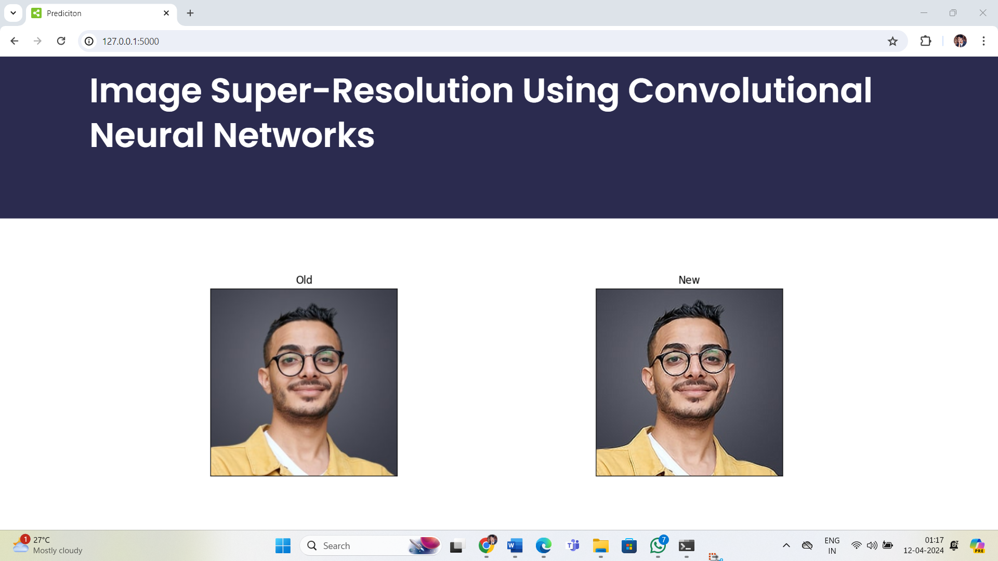

**Figure 4.3.3. After clicking on the improve image button the output shows the enhancement of the picture**



**Figure 4.3.4. Similarly we can check the same for other images too as shown**

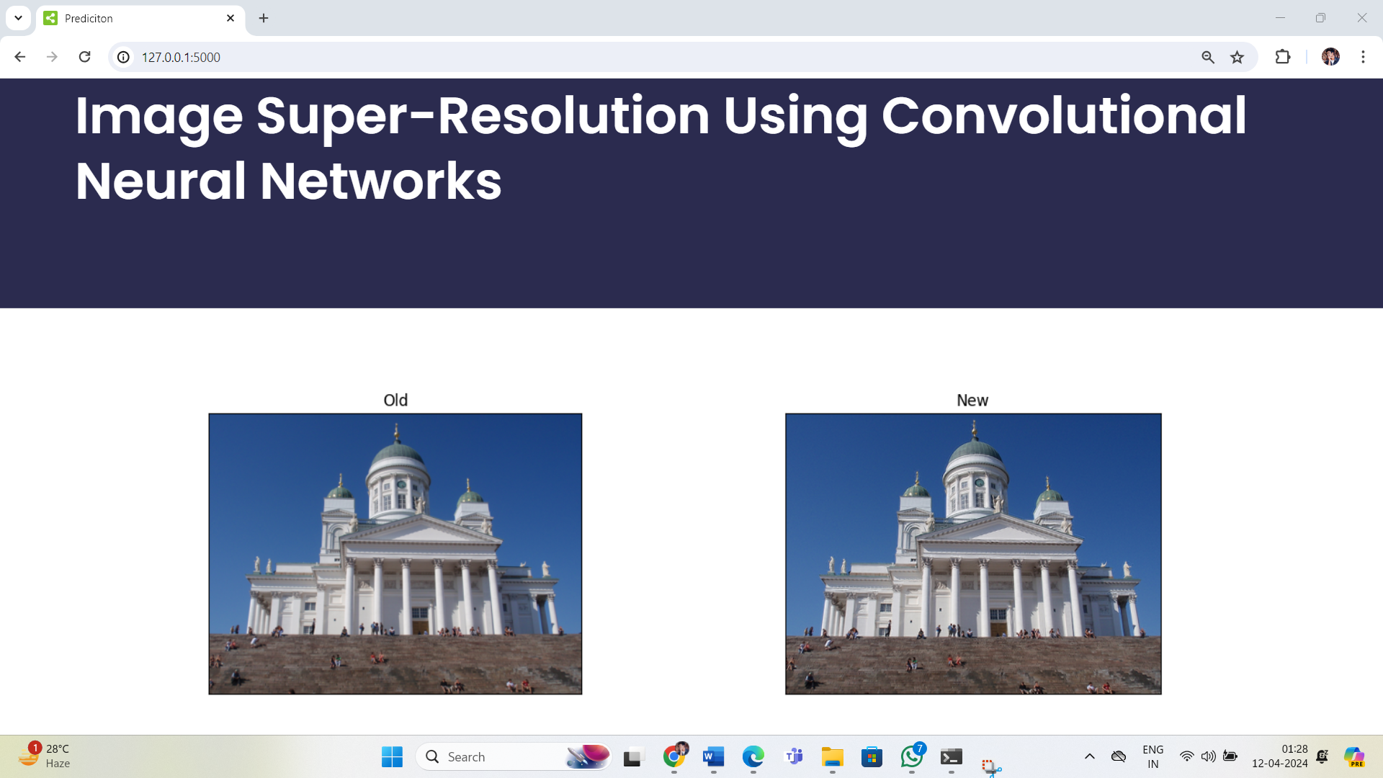

**Figure 4.3.5. We can observe the differences between the generated image and the uploaded image.**



**Figure 4.3.6. Similarly we can upload the images of animals**

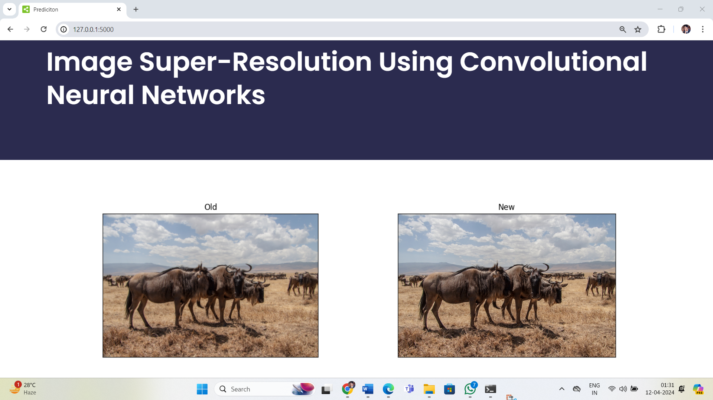

**Figure 4.3.7. The difference between the older image and new image is the clarity and the appearance.**

**4.4 Dataset:**

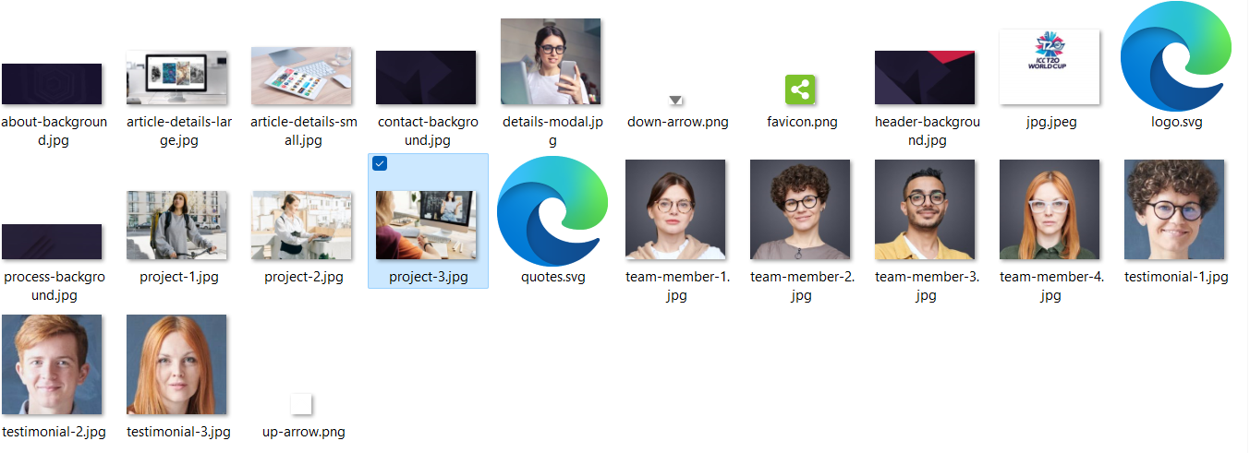

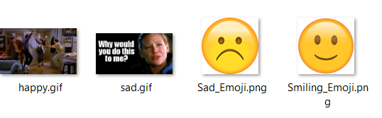

**Figure 4.4.1. This is the dataset which consists of the original images which needs to be tested.**

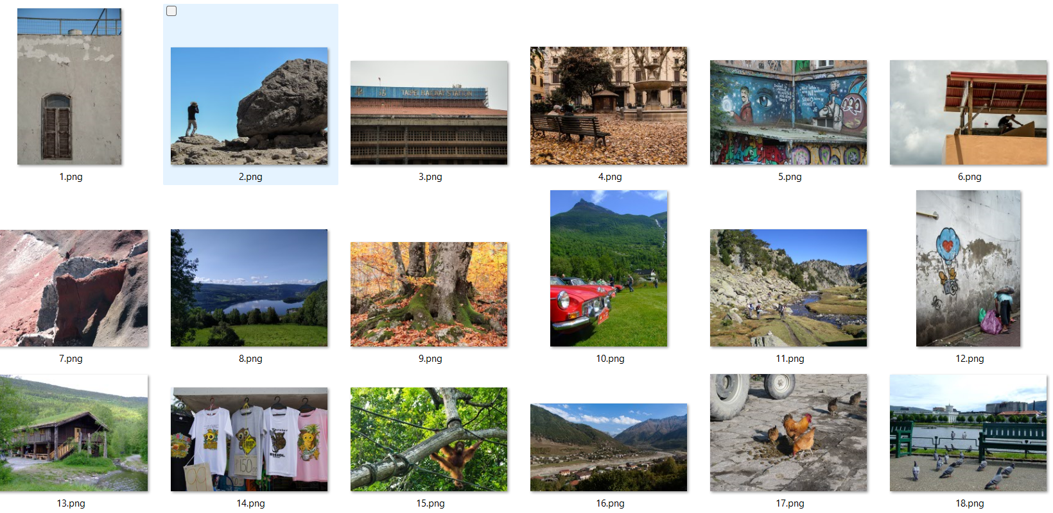

**Figure 4.4.2. This is the dataset of different things such as walls, houses, birds, stones, tree branches etc.**

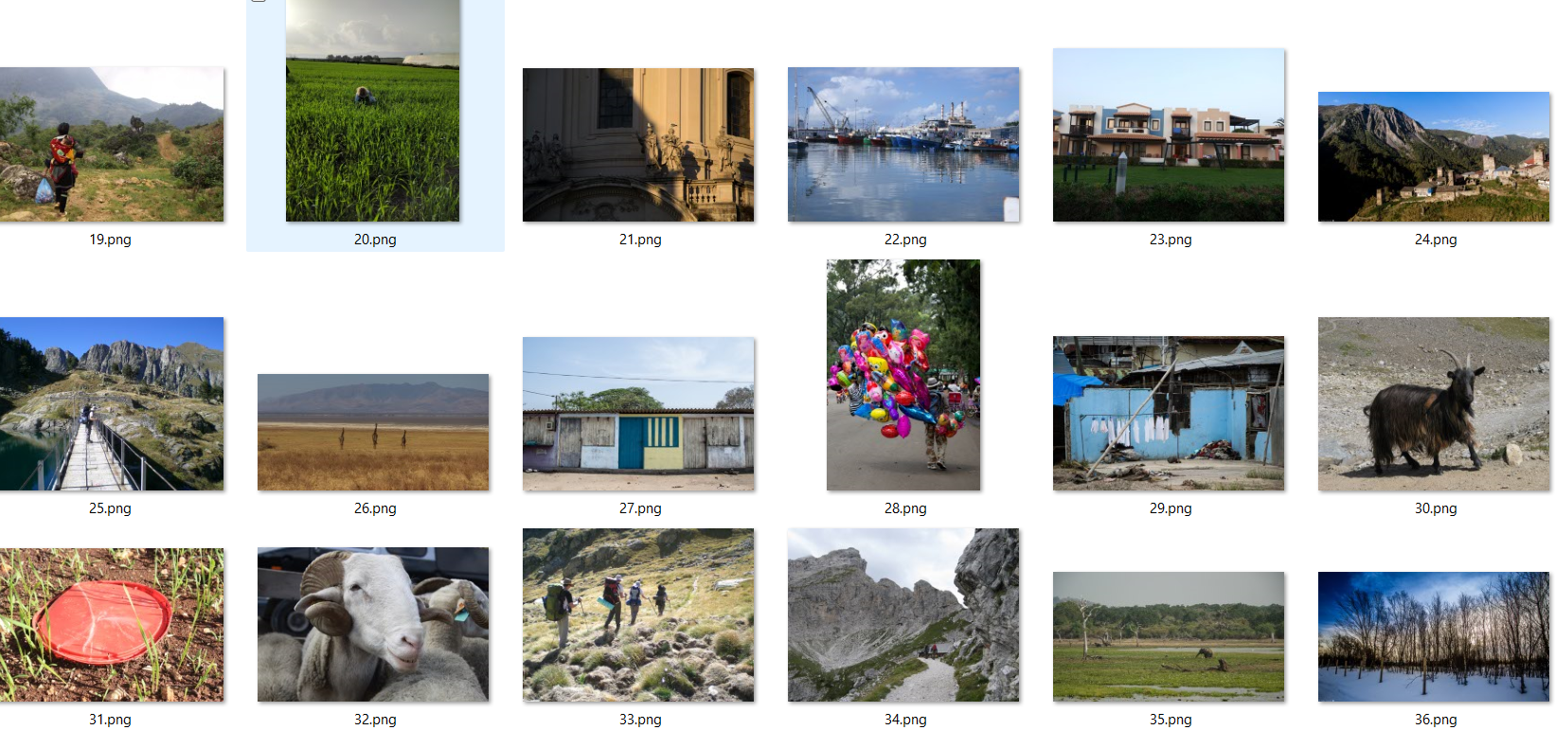

**Figure 4.4.3. This is the dataset which consists of animals, rocks, sea water etc.**

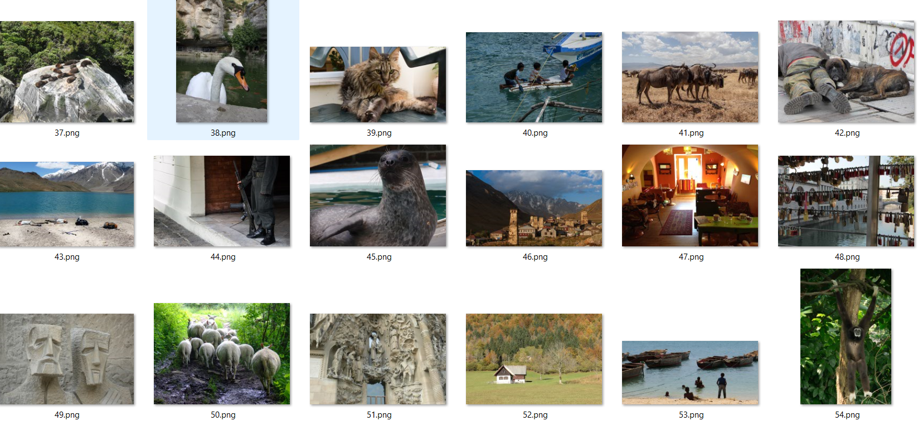

**Figure 4.4.4. This dataset consists of different kinds of animals.**

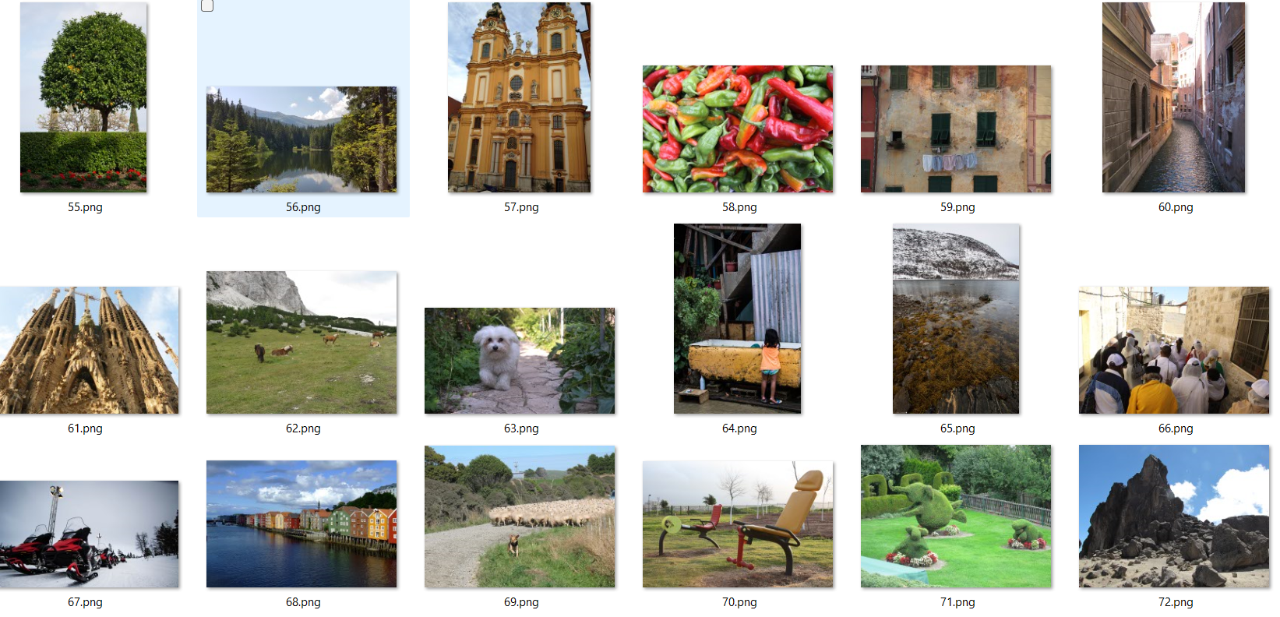

**Figure 4.4.5. This dataset consists of non-living things and living things**

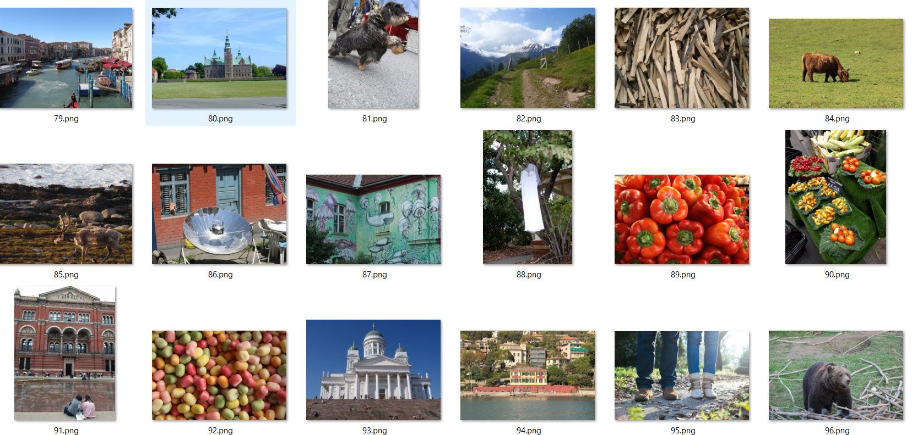

**Figure 4.4.6. This dataset consists of the eatables and different buildings, etc.**



**Figure 4.4.7. This dataset consists of different expressions of people etc.**

**4.5 Proposed Method:**

Algorithm ImageSuperResolution(images, LR_image)

Input: Set of LR Images, LR Image

#Stage 1: Model Selection and Initialization

selectedModel = SelectModel()

InitializeModel(selectedModel)

#Stage 2: Preprocessing

preprocessed_LR_image = PreprocessImage(LR_image)

#Stage 3:Model Interface

HR_image = SuperResolveImage(selectedModel, preprocessed_LR_image)

#Stage 4:Post Processing

postprocessed_HR_image = PostprocessImage(HR_image)

#Stage 5:output

DisplaySuperResolvedImage(postprocessed_HR_image)

End Algorithm

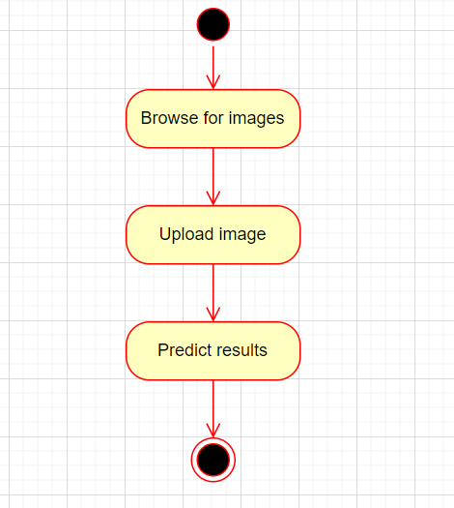

**Figure 4.5.1. Overview of super-resolution process**

**5. EXPERIMENTAL SETUP**

The Environment Used is PYTHON IDLE,COMMAND PROMPT,HTML,CSS,JAVA SCRIPT and the Frame work used is FLASK.

**5.1 Install Python IDLE – 3.11.4:**

To install Python IDLE 3.11.4, begin by visiting the official Python website and downloading the installer for your operating system. Once downloaded, run the installer and follow the on-screen instructions. During the installation process, ensure that the option to install IDLE is selected. After completing the installation, verify it by checking the installed Python version using the terminal or command prompt. Additionally, you can launch IDLE from your system's applications or by running it from the terminal/command prompt. If you're using Windows, consider setting the PATH environment variable to include Python's installation directory for easier access. Following these steps will successfully install Python IDLE 3.11.4 on you system.

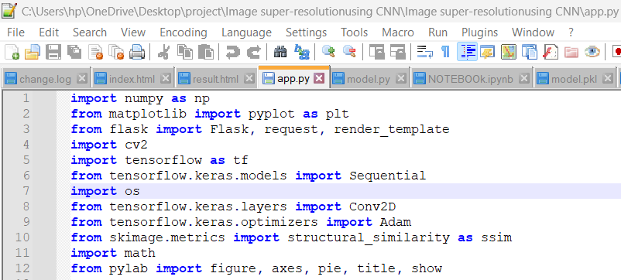

**Figure 5.1.1: Python IDLE**

**5.2 Connect with Command Prompt:**

To connect with IDLE using the Command Prompt, ensure that Python is installed on your system and its installation directory is added to the system's PATH environment variable. You can verify the Python installation by typing `python --version` in the Command Prompt, which should display the installed Python version. To open IDLE, simply type 54 `idle` in the Command Prompt and press Enter. This command launches the IDLE Python GUI editor, where you can write and execute Python code. If the `idle` command doesn't work, you may need to add Python's installation directory to the PATH variable manually or navigate to the Python installation directory in the Command Prompt. Once IDLE is open, you can run Python code directly within the IDLE editor and exit by closing the IDLE window or using the keyboard shortcut `Ctrl + D**.**

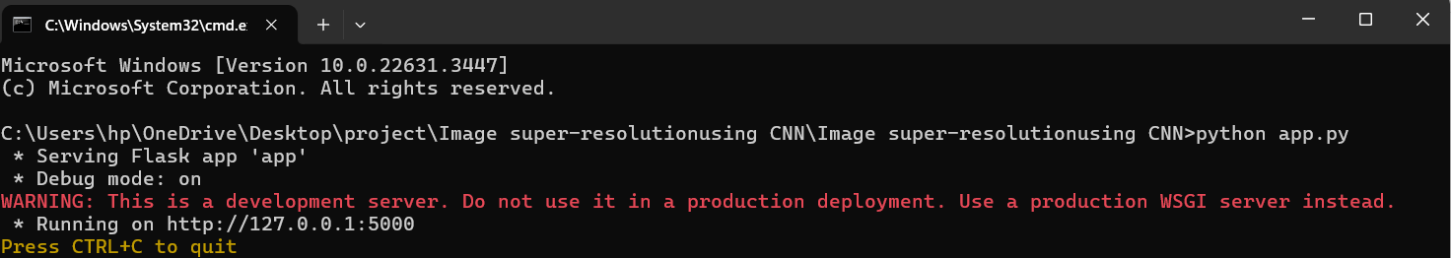

**Figure 5.2.1: Command Prompt**

**5.3 HTML:**

HTML, or HyperText Markup Language, is the standard markup language used to create and structure content on the World Wide Web. It serves as the foundation for building web pages and applications, providing a structured format for organizing text, images, multimedia, links, and interactive elements. HTML documents are interpreted by web browsers, which render them into visually appealing and interactive web pages for users to access and interact with.

At its core, HTML consists of a series of elements, each represented by opening and closing tags, which enclose content and define its purpose within the document. These elements are organized in a hierarchical structure, forming the building blocks of web pages. HTML elements can range from basic text formatting elements like <p> (paragraph) and <h1> to more complex interactive elements like <form> and <input>. Additionally, HTML supports attributes, which provide additional information or modify the behavior of elements. Attributes are specified within the opening tag of an element and are used to define characteristics such as the source of an image (src), the destination of a hyperlink (href), or the type of input in a form field (type).

HTML documents typically begin with a <!DOCTYPE> declaration, which specifies the HTML version being used, followed by the <html> element, which serves as the root of the document. Within the <html> element, developers define the document structure using elements like <head> for metadata and <body> for the main content. The <head> element contains information such as the document title (<title>), character encoding (<meta charset>), and links to external resources like stylesheets (<link>). The <body> element encapsulates the visible content of the document, including text, images, multimedia, and interactive elements.

One of the key principles of HTML is semantic markup, which involves using elements that convey meaning and structure to assistive technologies like screen readers and search engines. Semantic elements like <header>, <nav>, <main>, <section>, <article>, and <footer> provide context and clarity to the structure of web documents, enhancing accessibility and search engine optimization (SEO).

Over the years, HTML has evolved to incorporate new features and enhancements to meet the demands of modern web development. HTML5, the latest version of the HTML standard, introduced a range of new elements and attributes for multimedia (e.g., <video>, <audio>), graphics (e.g., <canvas>), forms (e.g., new input types like <email>, <date>), and semantic elements for structuring content. Additionally, HTML5 introduced the concept of web components, enabling developers to create reusable UI elements and custom widgets for building modular and scalable web applications.

HTML, or Hyper Text Markup Language, is the backbone of web development, providing the structure and content of web pages. It consists of a set of markup tags enclosed in angle brackets, defining elements like paragraphs, headings, images, links, and more. HTML documents are structured hierarchically, with a root <html> element containing <head> and <body> sections. Tags can have attributes providing additional information. HTML5 introduced semantic elements for clearer document structure. HTML documents start with a <!DOCTYPE> declaration, followed by metadata in the <head> section and content in the <body> section. HTML enables text formatting, lists, tables, links, and anchors, forming the foundation of web pages accessible across browsers and devices.The below is the source code of website created.

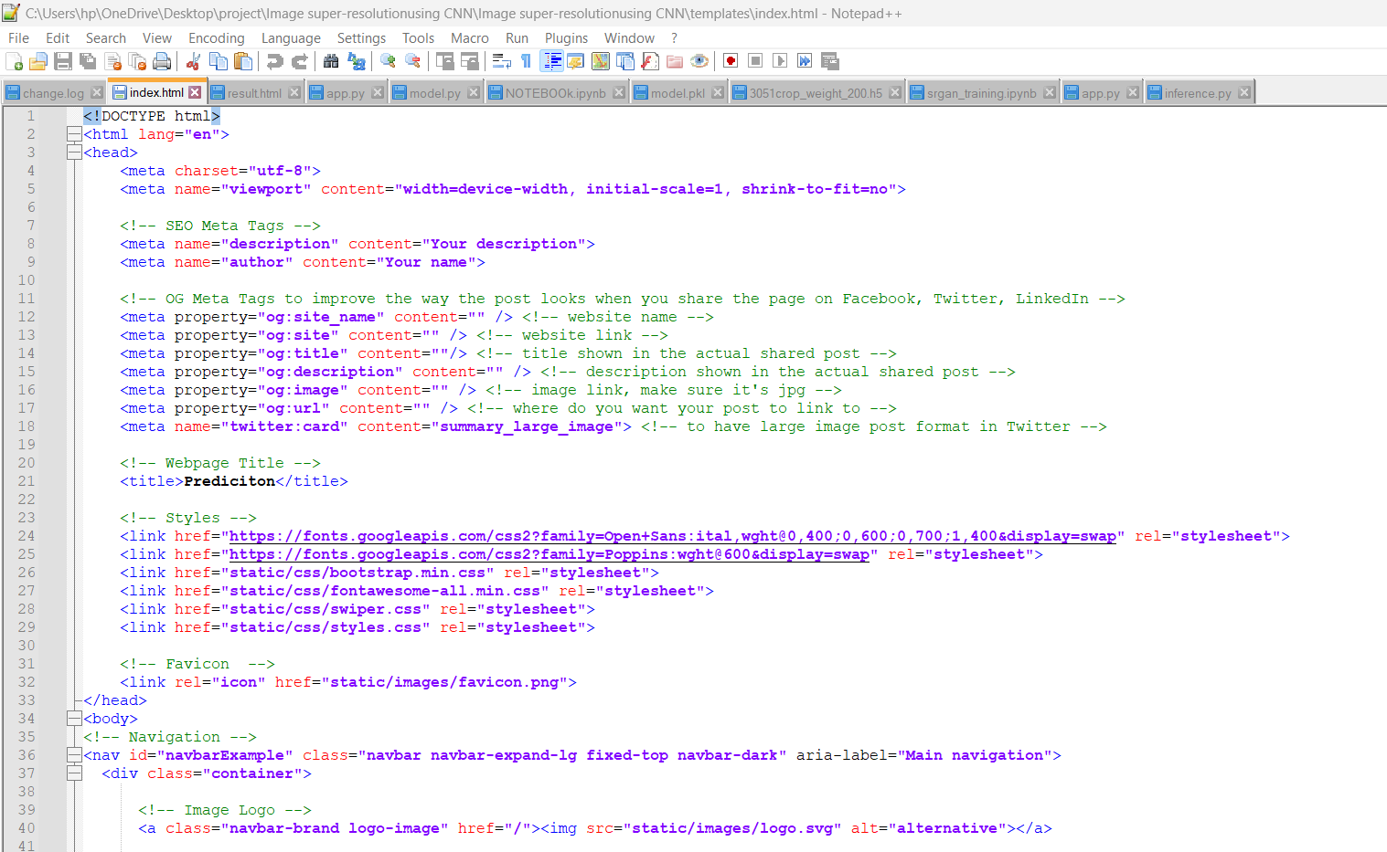

**Figure 5.3.1 source code of HTML**

**5.4 CSS:**

CSS, which stands for Cascading Style Sheets, is a styling language used to control the presentation and layout of HTML documents on the World Wide Web. It works alongside HTML to define the visual appearance of web pages, including aspects such as colors, fonts, spacing, layout, and responsive behavior. CSS enables developers to create visually appealing and user-friendly websites by specifying how HTML elements should be displayed on screen or in print.

CSS, which stands for Cascading Style Sheets, is a styling language used to control the presentation and layout of HTML documents on the World Wide Web. It works alongside HTML to define the visual appearance of web pages, including aspects such as colors, fonts, spacing, layout, and responsive behavior. CSS enables developers to create visually appealing and user-friendly websites by specifying how HTML elements should be displayed on screen or in print.

Key Concepts of CSS:

Selectors: CSS uses selectors to target HTML elements within a document and apply styling rules to them. Selectors can target elements based on their type (<h1>, <p>, etc.), class (<div class="...">), ID (<div id="...">), attributes, or relationships with other elements.

Properties: CSS properties define the visual characteristics of targeted elements, such as color, font size, margin, padding, border, background, and more. Each property can be assigned a value to specify the desired appearance.

Values: CSS properties accept values that determine how the styling should be applied. Values can be numerical (e.g., 10px, 2em), textual (e.g., red, Arial), or functional (e.g., rgb(255, 0, 0), calc(50% - 10px)).

Selectors and Properties Cascade: CSS follows a cascade mechanism, where styles are applied based on specificity and order of appearance. Specificity refers to the priority given to certain selectors over others, while the order of appearance determines which styles take precedence when conflicting rules are encountered.

Media Queries: CSS supports media queries, which allow developers to apply different styles based on the characteristics of the device or viewport, such as screen size, orientation, and resolution. Media queries enable responsive web design, where layouts adapt dynamically to various screen sizes and devices.

To streamline development and enhance productivity, developers often use CSS frameworks and preprocessors. CSS frameworks, such as Bootstrap and Foundation, provide pre-designed styles and components that can be easily customized and integrated into web projects. CSS preprocessors, such as Sass and Less, extend the capabilities of CSS by introducing features like variables, mixins, nesting, and functions, which improve code organization and maintainability.

In conclusion, CSS is an essential technology for web development, enabling developers to control the visual presentation of HTML documents and create engaging user experiences. By mastering CSS fundamentals and leveraging advanced techniques and tools, developers can design responsive, accessible, and aesthetically pleasing websites for diverse audiences across different devices and platforms.

In an image super-resolution project, CSS (Cascading Style Sheets) is instrumental in shaping the visual presentation and user experience of the web application or interface associated with the project. By applying CSS, developers can customize the appearance and layout of elements, ensuring a cohesive and appealing design that aligns with the project's objectives.

CSS allows for the styling of various user interface components such as buttons, input fields, and navigation menus, contributing to a consistent and visually pleasing layout. Furthermore, developers can utilize CSS to implement responsive design techniques, ensuring that the application adapts seamlessly to different screen sizes and devices.

**5.5 Java Script:**

JavaScript, often abbreviated as JS, stands as a cornerstone of modern web development, facilitating interactive and dynamic experiences across a vast array of digital platforms. Originally conceived by Netscape Communications in the mid-1990s, its evolution has been nothing short of transformative. Today, JavaScript is an integral part of the web ecosystem, powering everything from simple form validations to complex web applications.

At its core, JavaScript is a high-level, interpreted programming language, designed to be executed within web browsers. Its syntax draws inspiration from several programming paradigms, including procedural, functional, and object-oriented styles. This versatility enables developers to craft code that is not only efficient but also easily comprehensible, fostering collaboration and innovation within development teams.

One of JavaScript's defining features is its event-driven nature. Through event listeners, developers can respond to user interactions such as clicks, scrolls, and keystrokes, dynamically altering webpage content in real-time. This capability empowers developers to create engaging user experiences, enhancing usability and interactivity.

Moreover, JavaScript's ability to manipulate the Document Object Model (DOM) lies at the heart of its prowess. By accessing and modifying DOM elements, developers can dynamically update webpage content without requiring page reloads. This dynamic nature, coupled with asynchronous programming techniques like AJAX, forms the backbone of modern single-page applications (SPAs), which deliver seamless user experiences akin to desktop software.

JavaScript's influence extends beyond the client-side realm. With the advent of server-side JavaScript frameworks like Node.js, developers can now leverage JavaScript's capabilities on the server as well. This convergence of client and server-side technologies has spurred the development of full-stack JavaScript applications, streamlining development workflows and fostering code reuse across different layers of the application stack.

Furthermore, JavaScript's vibrant ecosystem is fueled by a myriad of libraries and frameworks, each catering to specific development needs and preferences. Frameworks like React, Angular, and Vue.js provide developers with powerful abstractions and component-based architectures, enabling the rapid development of complex user interfaces.

However, JavaScript's ubiquity is not without its challenges. Its permissiveness and loosely-typed nature can lead to subtle bugs and security vulnerabilities if not managed carefully. Additionally, the diverse landscape of JavaScript libraries and frameworks can be daunting for newcomers, necessitating a solid understanding of core JavaScript concepts before diving into advanced frameworks.

In conclusion, JavaScript's journey from its humble origins to its current status as a linchpin of web development epitomizes the dynamic nature of the digital landscape. Its versatility, coupled with its vibrant community and ever-evolving ecosystem, ensures that JavaScript will continue to shape the future of web development for years to come.

In an image super-resolution project, JavaScript serves as the backbone for enhancing the user interface's interactivity and functionality. By leveraging JavaScript, developers can create a dynamic and responsive user experience, facilitating various tasks such as image loading, processing, and result visualization.

One primary function of JavaScript in this project is facilitating dynamic image loading and manipulation. JavaScript enables users to upload low-resolution images directly from their devices or external sources. Once uploaded, JavaScript can handle the processing of these images, initiating the super-resolution algorithm to enhance their quality.

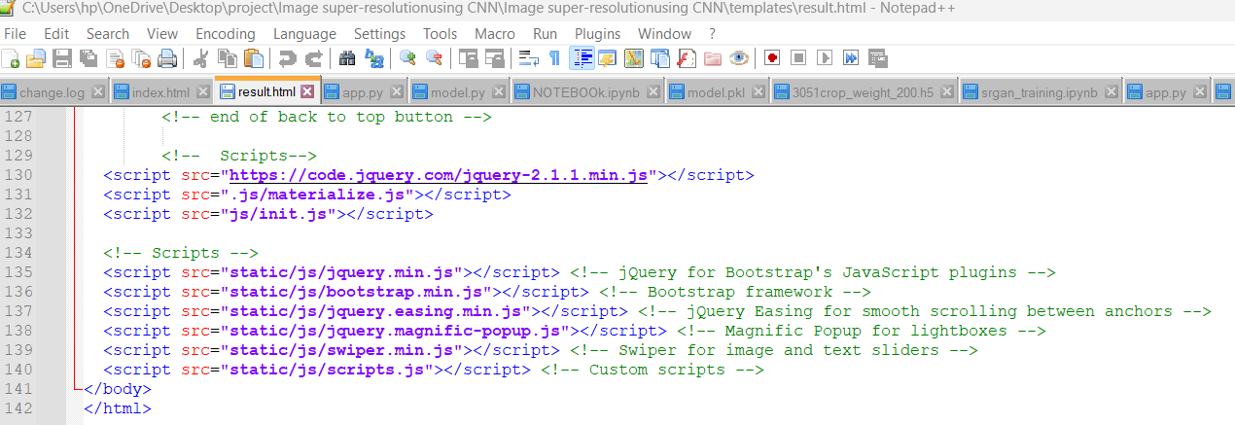

**5.5.1 Figure: Source code of Java Script**

**5.6 FLASK:**

Flask is a lightweight and flexible web application framework for Python. Born out of the desire to provide developers with a simpler and more modular alternative to larger frameworks like Django, Flask embraces the philosophy of minimalism and simplicity. Despite its lightweight nature, Flask remains powerful and extensible, making it a popular choice for building web applications, APIs, and microservices.

At its core, Flask provides the fundamental building blocks necessary for web development, including routing, request handling, and response generation. Its simplicity stems from its minimalist design, which emphasizes clarity and ease of use. Flask eschews unnecessary abstractions and conventions, allowing developers to structure their applications according to their preferences and requirements.

One of Flask's defining features is its reliance on the WSGI (Web Server Gateway Interface) standard, which enables interoperability with a wide range of web servers and deployment options. This flexibility allows Flask applications to be deployed on traditional web servers like Apache and Nginx, as well as modern platforms like Heroku, AWS, and Google Cloud Platform.

Flask's modular architecture encourages the use of extensions, which are third-party libraries that add additional functionality to the framework. These extensions cover a wide range of use cases, including database integration, authentication, form validation, and more. By leveraging extensions, developers can easily enhance their Flask applications with advanced features without reinventing the wheel.

Furthermore, Flask's lightweight nature makes it well-suited for building microservices and APIs. Its minimal overhead and efficient request handling make it ideal for handling high-throughput workloads and scaling horizontally. Combined with libraries like Flask-RESTful and Flask-SQLAlchemy, Flask provides developers with a powerful toolkit for building robust and scalable backend services.

Despite its simplicity, Flask remains highly customizable and extensible. Developers have the freedom to choose their preferred templating engine, database ORM, and authentication mechanism, allowing for a tailored development experience. Flask's extensive documentation and vibrant community further contribute to its appeal, providing developers with resources and support to tackle any challenge.

In conclusion, Flask's lightweight and flexible nature, combined with its simplicity and extensibility, make it a compelling choice for building web applications and APIs in Python. Whether you're a seasoned developer looking to streamline your workflow or a newcomer seeking a gentle introduction to web development, Flask offers a versatile and approachable framework for building modern web applications.

In an image super-resolution project, Flask serves as the backend framework responsible for handling server-side logic and facilitating communication between the client-side interface and the processing algorithms. With Flask, developers can create a robust backend infrastructure to support various functionalities required for the project.

At the core of Flask's functionality is its ability to define routes and endpoints that handle incoming requests from the client-side interface. These routes can include endpoints for uploading images, initiating super-resolution processing, and retrieving the processed images. Flask's routing mechanism allows developers to map URL patterns to specific functions, making it easy to organize and manage different aspects of the application's functionality.



**5.6.1 Figure: Web application using Flask**

**5.7 Libraries Used:**

**5.7.1 NUMPY:**

In the image super-resolution project, NumPy is pivotal for handling the numerical aspects of image data. Its role encompasses various critical functionalities within the project:

NumPy facilitates the representation of images as multi-dimensional arrays, enabling efficient storage and manipulation of pixel values. This representation is fundamental for processing images throughout the super-resolution pipeline.

NumPy provides essential tools for data preprocessing tasks. These include resizing, cropping, and normalization functions, ensuring that input images are appropriately formatted and prepared for super-resolution processing.

NumPy supports the implementation of the super-resolution algorithm itself. With its comprehensive suite of mathematical functions and efficient array operations, NumPy enables the execution of complex mathematical computations involved in the algorithm, such as convolution operations and interpolation.

NumPy assists in feature extraction from images, a crucial step in certain super-resolution techniques. By offering functions for calculating gradients, edges, and other image features, NumPy aids in identifying relevant patterns that contribute to enhancing image resolution.

NumPy's pivotal role in the image super-resolution project extends beyond mere numerical handling; it forms the bedrock of numerous critical functionalities within the project's pipeline. At the heart of its contributions lies the ability to represent images as multi-dimensional arrays, thereby enabling the efficient storage and manipulation of pixel values. This foundational representation not only facilitates seamless data processing but also serves as the cornerstone for all subsequent operations within the super-resolution framework.

Furthermore, NumPy's extensive toolkit encompasses a plethora of functionalities crucial for data preprocessing tasks. From resizing and cropping to normalization, NumPy empowers developers to ensure that input images are meticulously formatted and primed for the rigorous processing demands of super-resolution algorithms. Such preprocessing steps are indispensable for guaranteeing the integrity and consistency of the input data, thereby laying a solid foundation for the subsequent enhancement processes.

In addition to its indispensable role in data preparation, NumPy serves as a linchpin in the implementation of the super-resolution algorithm itself. Leveraging its comprehensive suite of mathematical functions and highly optimized array operations, NumPy facilitates the seamless execution of intricate computations inherent to the super-resolution process. Tasks such as convolution operations and interpolation, which lie at the core of many super-resolution techniques, are efficiently executed through NumPy's robust functionality suite, thereby driving the algorithmic advancements required for high-fidelity image enhancement.

Moreover, NumPy's versatility extends to the realm of feature extraction, a pivotal step in certain super-resolution methodologies. By offering a rich array of functions for calculating gradients, edges, and other salient image features, NumPy empowers developers to extract pertinent information crucial for guiding the super-resolution process. Through meticulous feature extraction, NumPy aids in identifying and preserving relevant patterns that contribute significantly to the enhancement of image resolution, thereby enriching the overall quality of the output imagery.

In essence, NumPy emerges as a cornerstone of the image super-resolution project, providing indispensable support across various stages of the pipeline. From data representation and preprocessing to algorithmic implementation and feature extraction, NumPy's robust capabilities and unparalleled efficiency empower developers to push the boundaries of image enhancement, ultimately paving the way for transformative advancements in digital imaging technology.

**5.7.2 MATPLOTLIB:**

Matplotlib's indispensable role in the image super-resolution project extends far beyond mere visualization; it serves as a cornerstone for gaining profound insights into the data and results of the super-resolution process. Leveraging Matplotlib's versatility and rich repertoire of plotting functions, developers can unravel intricate nuances within the data, facilitating informed decision-making and performance evaluation throughout the project's lifecycle.

At the outset of the super-resolution pipeline, Matplotlib plays a pivotal role in visualizing input images before any enhancement processing occurs. Through the seamless integration of Matplotlib's plotting functions, developers can meticulously scrutinize the characteristics and quality of the original images. This pre-processing visualization step allows for the identification of any anomalies or artifacts present in the input data, thereby laying the groundwork for subsequent enhancement endeavors.

As the super-resolution algorithm is applied to the input images, Matplotlib continues to be an invaluable asset for visualizing the resulting super-resolved images. By leveraging Matplotlib's plotting capabilities, developers can vividly portray the enhancements achieved through the algorithmic interventions. These visualizations not only facilitate qualitative assessments of image quality but also provide valuable insights into the efficacy of the super-resolution techniques employed.

Furthermore, Matplotlib empowers developers to conduct comprehensive comparisons between input images and their corresponding super-resolved versions. Through the creation of side-by-side visualizations, developers can directly juxtapose the original and enhanced images, facilitating a nuanced evaluation of the algorithm's performance. Such comparative analyses serve as a litmus test for gauging the algorithm's ability to faithfully reconstruct fine details and enhance overall image fidelity.

In essence, Matplotlib emerges as an indispensable ally in the image super-resolution project, enabling developers to traverse the intricacies of data visualization with unparalleled ease and sophistication. From pre-processing visualizations to post-enhancement analyses, Matplotlib's robust plotting capabilities empower developers to navigate the super-resolution landscape with clarity and precision, ultimately driving transformative advancements in image enhancement technology.

In the image super-resolution project, Matplotlib serves as an indispensable tool for visualizing various aspects of the data and results. Matplotlib's versatility and rich set of plotting functions enable developers to gain insights into the super-resolution process and evaluate the performance of the algorithm.

Matplotlib facilitates the visualization of input images before super-resolution processing. By displaying the original images using Matplotlib's plotting functions, developers can examine the characteristics and quality of the input data, identifying any artifacts or imperfections that may affect the super-resolution process.

Once the super-resolution algorithm is applied, Matplotlib enables the visualization of the resulting super-resolved images. By plotting the enhanced images, developers can visually assess the effectiveness of the algorithm in enhancing image quality and recovering fine details.

Matplotlib also supports the comparison of input images with their corresponding super-resolved versions. Developers can create side-by-side visualizations of input and output images, allowing for direct comparison and evaluation of the algorithm's performance.

**5.7.3 SYS:**

In the context of a software project, "SYS" typically refers to the system module or package in Python, which provides access to system-specific parameters and functions. However, it seems that you might be referring to a specific acronym or abbreviation "SYS" within our project that is not standard or commonly used in the context of software development.

Within our project framework, "SYS" could denote System Integration Services, a critical component responsible for orchestrating the seamless interaction between various modules, APIs, and external services. This interpretation underscores the importance of bridging disparate systems and technologies to ensure interoperability and data exchange, ultimately enhancing the project's functionality and efficiency. By encapsulating complex integration logic and facilitating communication across different components, System Integration Services enable our project to leverage the synergies of interconnected systems, fostering a cohesive and unified ecosystem.

Alternatively, "SYS" may represent a focus on Systematic Analysis and Optimization, reflecting our project's commitment to methodical examination and enhancement of system performance. Within this context, SYS encompasses a suite of tools, methodologies, and processes aimed at identifying bottlenecks, inefficiencies, and optimization opportunities within our project infrastructure. Through systematic analysis of system metrics and performance benchmarks, SYS empowers our team to implement targeted interventions and enhancements, driving improvements in reliability, scalability, and responsiveness.

In another interpretation, "SYS" could signify System Architecture and Design, emphasizing the foundational principles and structural framework guiding the development of our project. Within this framework, SYS encompasses the architectural patterns, design principles, and deployment strategies shaping the project's structural integrity and evolution. From defining system components and their interactions to establishing architectural patterns and deployment strategies, SYS encapsulates the overarching design rationale underpinning our project's development efforts, ensuring scalability, maintainability, and adaptability.

Moreover, "SYS" might encompass a variety of other contextual interpretations within our project domain, ranging from Systemic Risk Management to Systemic Innovation Strategies, depending on the specific requirements, objectives, and stakeholders involved. To accurately discern the meaning and implications of "SYS" within our project, it's imperative to delve into the specific context, domain, and strategic priorities shaping its usage and significance. By elucidating its meaning and relevance within our project ecosystem, we can gain deeper insights into its role in shaping our project's functionality, performance, and strategic direction, ultimately driving transformative advancements and delivering value to stakeholders.

**5.7.4 KERAS:**

In an image super-resolution project, Keras serves as a foundational component for implementing deep learning models aimed at enhancing image quality. Keras, renowned for its simplicity and flexibility, offers a user-friendly interface for constructing and training neural networks, streamlining the development process.

One of Keras' primary utilities lies in model development. Developers can leverage its high-level API to define the architecture of the super-resolution model, specifying layers, activation functions, and optimization algorithms effortlessly. With a diverse range of pre-built layers available, such as convolutional, pooling, and upsampling layers, Keras facilitates the construction of sophisticated models tailored to the specific requirements of image enhancement tasks.

Keras' ease of use makes it ideal for rapid prototyping and experimentation. Its intuitive design abstracts away much of the complexity inherent in deep learning, enabling developers to iterate quickly and explore various architectural configurations and hyperparameters effectively.

Keras' flexibility extends to customizations, allowing developers to define bespoke loss functions, metrics, and callbacks. This adaptability is invaluable for fine-tuning the super-resolution model, enabling developers to tailor the training process to optimize performance and meet project objectives.

Intimately integrated with TensorFlow, Keras inherits the robust capabilities of this powerful deep learning framework. This integration enables seamless utilization of TensorFlow functionalities within Keras, including distributed training, GPU acceleration, and deployment to production environments, enhancing scalability and performance.

Keras serves as an indispensable cornerstone in the realm of image super-resolution projects, where its simplicity and versatility are celebrated attributes. Leveraging Keras within such projects not only expedites the implementation of deep learning models but also ensures a smooth and intuitive development journey.

At the heart of Keras' utility lies its role in model development. Developers find solace in its high-level API, which empowers them to effortlessly sculpt the architecture of their super-resolution models. By seamlessly specifying layers, activation functions, and optimization algorithms, Keras liberates developers from the nitty-gritty details, enabling them to focus on the creative aspect of model design.

Moreover, Keras presents a treasure trove of pre-built layers, ranging from fundamental convolutional layers to advanced upsampling layers. This diverse arsenal empowers developers to craft intricate models finely attuned to the nuances of image enhancement tasks. Whether it's refining textures or sharpening details, Keras equips developers with the tools needed to achieve remarkable results.

The allure of Keras extends beyond mere model construction; it fosters a culture of rapid prototyping and experimentation. With its intuitive interface, Keras beckons developers to dive into the realm of exploration, where they can swiftly iterate through various architectural configurations and hyperparameters. This iterative process, facilitated by Keras' user-friendly design, paves the way for innovation and discovery.

Furthermore, Keras' adaptability knows no bounds, offering developers the freedom to customize every facet of the model training process. From crafting bespoke loss functions to defining personalized metrics and callbacks, Keras empowers developers to fine-tune their models with precision. This level of customization proves invaluable in optimizing model performance and aligning with project objectives.

Crucially, Keras' symbiotic relationship with TensorFlow fortifies its standing as a preferred choice for deep learning endeavors. Seamlessly integrated with TensorFlow, Keras harnesses the full might of this robust framework, unlocking a plethora of functionalities such as distributed training, GPU acceleration, and seamless deployment to production environments. This integration not only enhances scalability and performance but also ensures compatibility with industry standards and best practices.

In essence, Keras stands as a beacon of innovation and accessibility in the realm of image super-resolution, empowering developers to transcend boundaries and unleash the full potential of deep learning technology.

**5.7.5 SKIMAGE:**

In an image super-resolution project, the scikit-image (skimage) library serves as a fundamental tool for a variety of image processing tasks. Skimage, built on top of NumPy and SciPy, offers a comprehensive set of functionalities for manipulating, analyzing, and enhancing digital images.

One primary application of skimage in the project is image preprocessing. Skimage provides utilities for loading images from various file formats and performing preprocessing operations such as resizing, cropping, and adjusting image attributes like contrast and brightness. These preprocessing steps are crucial for preparing input images before feeding them into the super-resolution model.

skimage offers a wide range of image filtering and enhancement techniques. These include common operations such as Gaussian smoothing, median filtering, and histogram equalization, which can be applied to improve image quality or highlight specific features before super-resolution processing.

Skimage also plays a role in feature extraction, providing functions for detecting edges, corners, textures, and other image attributes. These extracted features can be used to guide the super-resolution process or to identify regions of interest within the images.

The scikit-image (skimage) library stands as an indispensable ally in the realm of image super-resolution projects, where its rich assortment of image processing functionalities proves invaluable. By building upon the robust foundations of NumPy and SciPy, skimage offers a versatile toolkit for a myriad of image manipulation and analysis tasks, elevating the quality and clarity of digital imagery.

At the forefront of skimage's contributions lies its pivotal role in image preprocessing. Within the project's pipeline, skimage's utilities shine as they deftly handle tasks ranging from loading images in diverse formats to performing essential preprocessing operations. Whether it's resizing images to conform to model input dimensions or fine-tuning attributes like contrast and brightness, skimage's prowess ensures that input images are primed for optimal performance within the super-resolution framework.

Moreover, skimage's repertoire extends to encompass a plethora of image filtering and enhancement techniques, each serving as a potent tool in the quest for image perfection. From the subtle smoothing effects of Gaussian filters to the robust noise reduction capabilities of median filtering, skimage empowers developers to wield a diverse arsenal of techniques, tailored to the unique demands of each image. Furthermore, histogram equalization emerges as a powerful ally, bestowing images with enhanced contrast and clarity, thereby laying the groundwork for subsequent super-resolution processing.

Beyond mere preprocessing and enhancement, skimage assumes a pivotal role in feature extraction—a task of paramount importance in guiding the super-resolution process. Leveraging skimage's suite of feature detection functions, developers can discern intricate details within images, from edges and corners to textures and patterns. These extracted features serve as beacons, illuminating areas of significance within the image landscape and providing invaluable guidance to the super-resolution model as it endeavors to reconstruct high-resolution imagery from its low-resolution counterparts.

In essence, the scikit-image library emerges as a linchpin in the image super-resolution journey, bridging the gap between raw imagery and refined visual masterpieces. With its robust feature set and intuitive interface, skimage empowers developers to wield the power of image processing with finesse, propelling their projects towards new heights of clarity, detail, and aesthetic appeal.

**5.7.6 CV2:**

In an image super-resolution project, the OpenCV library (often imported as cv2 in Python) plays a pivotal role in various stages of the image processing pipeline. OpenCV, renowned for its extensive collection of functions and algorithms, offers a robust toolkit for performing a wide range of tasks, from basic image manipulation to advanced computer vision operations.

One primary application of OpenCV in the project is image loading and preprocessing. With OpenCV, developers can effortlessly load images from different file formats and perform essential preprocessing tasks such as resizing, cropping, and adjusting image attributes like brightness and contrast. These preprocessing steps are essential for preparing the input data before applying super-resolution algorithms.

OpenCV provides a rich set of image filtering and enhancement techniques, including blurring, sharpening, and denoising filters. These techniques can be applied to improve image quality or highlight specific features before the super-resolution process.

OpenCV offers functionalities for feature extraction, enabling developers to detect and extract various image features such as edges, corners, and keypoints. These extracted features can be utilized to guide the super-resolution process or to identify regions of interest within the images.

OpenCV includes implementations of different super-resolution algorithms, allowing developers to directly apply these algorithms to enhance the resolution of low-quality images.

OpenCV, short for Open Source Computer Vision Library, is an open-source computer vision and machine learning software library. Initially developed by Intel in the late 1990s, OpenCV has since grown into a comprehensive toolset used extensively in various fields such as robotics, augmented reality, facial recognition, and medical image analysis.

One of the key strengths of OpenCV lies in its versatility and wide-ranging capabilities. It provides a plethora of functions and algorithms for processing, analyzing, and manipulating images and videos. From basic tasks like image loading, resizing, and color space conversion to more advanced operations such as feature detection, object tracking, and 3D reconstruction, OpenCV offers a comprehensive suite of tools to tackle virtually any computer vision task.

At the core of OpenCV's functionality are its image processing algorithms. These include filters for smoothing, sharpening, and edge detection, as well as techniques for morphological operations like dilation, erosion, and contour detection. OpenCV also provides support for various feature detection and description algorithms, such as SIFT (Scale-Invariant Feature Transform) and SURF (Speeded-Up Robust Features), which are crucial for tasks like object recognition and image stitching.

In addition to image processing, OpenCV excels in the realm of machine learning and computer vision algorithms. It includes implementations of popular machine learning algorithms such as support vector machines (SVM), k-nearest neighbors (KNN), and decision trees, which can be used for tasks like classification, regression, and clustering. Moreover, OpenCV seamlessly integrates with other machine learning frameworks like TensorFlow and PyTorch, allowing developers to leverage deep learning models for more complex tasks such as object detection and semantic segmentation.

OpenCV's cross-platform nature is another key advantage, as it supports various operating systems including Windows, macOS, Linux, iOS, and Android. This makes it accessible to a wide range of developers and ensures compatibility across different platforms and devices.

Overall, OpenCV stands as a cornerstone in the field of computer vision, empowering developers and researchers with the tools and algorithms needed to tackle a diverse array of image and video processing challenges. Its rich feature set, combined with its open-source nature and extensive documentation, has cemented its position as a go-to library for anyone working in the field of computer vision.

**5.7.7 OS:**

The OS module in Python serves as a vital interface for interacting with the underlying operating system. It empowers developers to execute a wide array of system-related tasks seamlessly. By providing functions for file and directory manipulation, command 55 execution, and process management, the OS module enables efficient system operations within Python scripts. Developers can leverage its capabilities to create, delete, move, and rename files and directories, streamlining file system interactions. Moreover, the module facilitates access to crucial system information, such as the current working directory, platform details, and environment variables. The "os" module in Python serves as a bridge between Python programs and the underlying operating system, providing a rich set of functionalities to interact with system resources. Through the "os" module, Python programs gain the ability to perform a wide range of tasks related to file management, process management, environment variables, and more.One of the primary uses of the "os" module is file and directory operations. Developers can utilize functions like os.listdir() to list the contents of directories, os.mkdir() to create new directories, and os.remove() to delete files.

The "os" module in Python serves as a critical interface between Python programs and the underlying operating system, furnishing a comprehensive toolkit for managing various aspects of the operating environment. Its extensive functionality spans file system operations, process management, environment variable manipulation, and system-specific interactions, empowering developers to write robust, platform-independent code.

File and Directory Operations:

At the core of the "os" module lies its capability to manipulate files and directories. With functions like os.listdir(), os.mkdir(), and os.remove(), developers can easily navigate, create, delete, and modify files and directories. Moreover, the module offers platform-independent path manipulation utilities through functions like os.path.join() and os.path.exists(), ensuring seamless compatibility across different operating systems. These functionalities streamline file system interactions, enabling developers to efficiently manage file resources within their Python applications.

Process Management:

The "os" module provides a suite of functions for managing processes, enabling developers to interact with running processes and execute system commands. With os.system(), developers can execute shell commands directly from their Python scripts, facilitating integration with system utilities and external programs. Additionally, functions like os.spawn*() and os.exec*() offer finer control over process creation and execution, allowing developers to manipulate process attributes and execute programs with specific parameters. Furthermore, the module provides access to process-related information such as process IDs (os.getpid()) and the ability to send signals to processes (os.kill()), enabling advanced process management capabilities within Python applications.

Environment Variable Manipulation:

Environment variables play a crucial role in configuring program behavior and sharing information between processes. The "os" module offers functions like os.getenv() and os.putenv() for accessing and modifying environment variables, respectively. These functions enable developers to read environment variables from the operating system environment and set new values as needed. By leveraging environment variables, developers can configure their Python applications dynamically, adapting to different execution environments and system configurations with ease.

Miscellaneous Operating System Functions:

In addition to file system operations, process management, and environment variable manipulation, the "os" module provides a range of miscellaneous functions for interacting with the operating system. For instance, functions like os.chmod() enable developers to modify file permissions, while os.chdir() allows for changing the current working directory within a Python script. Furthermore, the module exposes system-specific constants such as os.name and os.sep, providing insight into the underlying operating system environment and facilitating platform-specific behavior within Python applications.

Overall, the "os" module serves as a versatile and indispensable component of the Python standard library, empowering developers to interact with the operating system at a low level while maintaining platform independence. By providing a unified interface for file system operations, process management, environment variable manipulation, and system-specific interactions, the "os" module facilitates the development of robust, portable, and scalable Python applications across diverse operating environments.

**5.7.8 PICKLE:**

Pickle, a module in Python's standard library, serves as a versatile tool for serializing and deserializing Python objects efficiently. Serialization, the process of converting Python objects into byte streams, and deserialization, the reverse process, enable the preservation and reconstruction of object states across different Python sessions or for data transmission purposes.

One of Pickle's notable features is its binary format, which ensures efficient storage and retrieval of serialized data while maintaining the original structure and data types of Python objects. This binary format contributes to Pickle's compatibility with a wide range of Python objects, including lists, dictionaries, classes, and custom objects, without requiring additional configuration.

Pickle also offers customization options through special methods and subclassing, allowing developers to control the serialization and deserialization process according to specific requirements. However, it's important to exercise caution when deserializing data from untrusted sources due to the potential security risks associated with executing arbitrary Python code during deserialization.

Pickle, nestled within Python's expansive standard library, emerges as a versatile powerhouse for the seamless serialization and deserialization of Python objects. This dynamic module facilitates the conversion of Python objects into byte streams for efficient storage, transmission, or long-term preservation, and effortlessly reconstructs them back into their original state when needed, even across different Python sessions or environments.

At the heart of Pickle's prowess lies its binary format, meticulously designed to balance efficiency with fidelity. This format ensures not only compact storage of serialized data but also faithful reconstruction of the original structure and data types of Python objects during deserialization. Whether it's a complex nested data structure, a custom class instance, or a dictionary with heterogeneous elements, Pickle deftly preserves their essence without sacrificing efficiency, making it an ideal choice for a myriad of serialization tasks.

Furthermore, Pickle's versatility extends to its compatibility with a vast array of Python objects straight out of the box. From built-in data types like lists and dictionaries to user-defined classes and instances, Pickle seamlessly handles serialization and deserialization with minimal configuration overhead. This broad compatibility simplifies the serialization process, allowing developers to focus on their application logic rather than grappling with compatibility issues or data conversion complexities.

In addition to its out-of-the-box functionality, Pickle empowers developers with customization options through special methods and subclassing. By implementing __reduce__() and __reduce_ex__() methods or subclassing the pickle.Pickler and pickle.Unpickler classes, developers gain fine-grained control over the serialization and deserialization process. This flexibility enables tailored handling of complex data structures, optimization of serialization performance, and integration with custom storage or transmission protocols.

However, it's essential for developers to tread cautiously when dealing with Pickle, particularly when deserializing data from untrusted sources. The inherent flexibility of Pickle comes with a potential security trade-off, as deserializing maliciously crafted or tampered data may inadvertently execute arbitrary Python code, leading to security vulnerabilities or unexpected behavior. To mitigate these risks, it's crucial to validate and sanitize input data, employ safe loading techniques such as pickle.load() with a trusted File object, and adhere to best practices for secure application design and deployment.

In summary, Pickle stands as a cornerstone in the Python ecosystem, offering a potent blend of efficiency, versatility, and customization for serialization and deserialization tasks. Its binary format ensures compact yet faithful representation of Python objects, while its compatibility and customization options empower developers to tackle a wide range of serialization challenges with confidence and finesse. However, prudent usage and adherence to security practices are paramount to harnessing Pickle's capabilities safely and effectively in Python applications.

**5.7.9.STREAMLIT:**

Streamlit is a Python library designed to streamline the creation of interactive web applications for data science and machine learning projects. With its intuitive API and user-friendly interface, Streamlit empowers developers to build sophisticated web applications directly from Python scripts without the need for extensive web development expertise.

One of Streamlit's key strengths lies in its simplicity. By leveraging familiar Python syntax and data science libraries, developers can rapidly prototype and deploy interactive applications with minimal effort. Streamlit's extensive library of built-in widgets enables users to incorporate interactive elements such as sliders, dropdowns, and checkboxes seamlessly into their applications, facilitating real-time data exploration and visualization.

Streamlit seamlessly integrates with popular data visualization libraries like Matplotlib, Plotly, and Altair, allowing developers to create dynamic charts, plots, and dashboards effortlessly. This tight integration enables developers to focus on data analysis and visualization tasks without getting bogged down by the complexities of web development.

Streamlit stands as a beacon of simplicity and efficiency in the realm of web application development for data science and machine learning projects. With its intuitive API and straightforward interface, Streamlit revolutionizes the process of creating interactive web applications, democratizing access to web development for Python developers of all backgrounds.

At the core of Streamlit's appeal lies its unparalleled simplicity. By harnessing the power of Python's familiar syntax and leveraging popular data science libraries, developers can swiftly translate their ideas into fully functional web applications with minimal friction. Streamlit's seamless integration with Python's ecosystem allows developers to focus on their core data science tasks, rather than wrestling with the complexities of web development frameworks or frontend technologies.

A standout feature of Streamlit is its extensive library of built-in widgets, which empowers developers to incorporate interactive elements effortlessly. From simple sliders and dropdowns to more complex widgets like date pickers and file uploaders, Streamlit provides a rich palette of tools for creating dynamic user interfaces. These widgets enable real-time data exploration and manipulation, fostering a responsive and engaging user experience within the web application.

Moreover, Streamlit's seamless integration with popular data visualization libraries further enhances its appeal. By seamlessly interfacing with libraries such as Matplotlib, Plotly, and Altair, Streamlit empowers developers to create stunning charts, plots, and dashboards with ease. This tight integration eliminates the need for manual configuration or data conversion, allowing developers to focus on crafting insightful visualizations that effectively communicate their findings to end-users.

Beyond its simplicity and integration capabilities, Streamlit embodies a philosophy of democratizing web development for data science. By lowering the barrier to entry and providing a straightforward pathway for creating interactive web applications, Streamlit empowers data scientists, researchers, and developers to share their insights and findings with a broader audience. This democratization of web development not only accelerates the pace of innovation but also fosters collaboration and knowledge sharing within the data science community.

In essence, Streamlit transcends the traditional boundaries of web development, offering a seamless and intuitive platform for creating interactive data science applications. Its simplicity, integration with Python's ecosystem, and commitment to accessibility position Streamlit as a transformative tool in the arsenal of data scientists and developers seeking to unlock the full potential of their data.

**5.8 Parameters:**

**5.8.1 PEAK SIGNAL-TO-NOISE RATIO (PSNR)**

**𝑷𝑺𝑵𝑹 = 𝟏𝟎 ∗ 𝒍𝒐𝒈𝟏𝟎((𝒑𝒆𝒂𝒌^𝟐) 𝑴𝑺𝑬**

Peak Signal-to-Noise Ratio (PSNR) serves as a fundamental metric in image processing and compression, providing a quantitative measure of the fidelity of a reconstructed image compared to its original counterpart.

As a widely used quality assessment metric, PSNR quantifies the level of distortion introduced during image compression or processing by evaluating both the magnitude of the noise and the maximum possible signal strength.

PSNR is calculated as the ratio of the peak signal power to the mean squared error between the original and reconstructed images, expressed in decibels (dB). A higher PSNR value indicates a higher level of fidelity, with larger values implying less perceptible distortion.

This makes PSNR invaluable in evaluating the performance of image compression algorithms, encoding techniques, and image processing operations, enabling researchers and practitioners to fine-tune their algorithms and parameters to achieve optimal visual quality while minimizing data loss.

Despite its widespread use, it's important to note that PSNR has limitations, particularly in scenarios involving perceptually sensitive images or complex visual content, where human perception may not correlate perfectly with PSNR measurements. Nonetheless, as a simple and widely understood metric, PSNR continues to play a pivotal role in the evaluation and optimization of image processing and compression systems.

• PSNR is a measure of the quality of a encoded image compared to an original reference image.

• PSNR values above 30 dB are generally considered high and indicative of good image quality.

• The peak pixel value in the picture is represented by the variable "peak". It shows the highest possible value that a pixel in the picture may have. The highest pixel value for an 8-bit picture is 255 (28 - 1), hence "peak" would typically be 255 for normal 8-bit images.

• Measurement of Image Quality: PSNR is a widely used metric for assessing the quality of an image after it has undergone compression or other processing. It quantifies the fidelity of the processed image compared to the original, serving as a critical tool in image quality evaluation.

• Decibel Scale: PSNR is expressed in decibels (dB), which is a logarithmic scale. The decibel scale is particularly useful because it provides a convenient way to express large ranges of image quality. Higher PSNR values indicate better image quality.

**5.8.2. MEAN SQUARE ERROR (MSE):**

𝑴𝑺𝑬 = ( 𝟏 𝒎∗𝒏 ) ∗ 𝜮(𝜮(𝑰(𝒙, 𝒚) − 𝑲(𝒙, 𝒚))^𝟐)

Mean Squared Error (MSE) serves as a cornerstone metric in the realm of image processing, providing a quantitative measure of the discrepancy between an original image and its reconstructed counterpart. This fundamental metric calculates the average squared difference between corresponding pixel values of the original and reconstructed images.

MSE is computed by taking the squared difference between each pixel value in the original and reconstructed images, summing up these squared differences across all pixels, and then dividing by the total number of pixels. This process yields a single numerical value representing the average squared difference per pixel between the two images.

MSE is a widely used metric in image processing and compression tasks, providing a quantitative assessment of reconstruction quality. A lower MSE value indicates better reconstruction fidelity, as it signifies smaller differences between the original and reconstructed images. However, MSE is sensitive to outliers and does not necessarily correlate perfectly with human perception of image quality.Despite its limitations, MSE serves as a valuable tool for algorithm optimization, parameter tuning, and comparative analysis in image processing applications. It provides a standardized and objective measure of reconstruction accuracy, enabling researchers and practitioners to quantify and improve the performance of image processing algorithms and systems.

• m and n are the dimensions of the image (e.g., width and height).

• I(x, y) represents the pixel value of the original image at position (x, y).

• K(x, y) represents the pixel value of the reconstructed (or compressed) image at the same position.

• MSE measures the average squared difference between the pixel values of the original image and encoded image.

• MSE values close to zero suggest minimal distortion and high image fidelity.

• Mathematical Calculation: It computes the average of the squared pixel-wise differences between the corresponding pixels of the two images.

• Minimal Distortion: An MSE value close to zero indicates that there is minimal distortion or difference between the original and processed image.

• Image Fidelity: In the context of image processing, low MSE values suggest high image fidelity, meaning the processed image closely resembles the original, maintaining image quality and detail.

• Quality Assessment: MSE is a crucial tool for evaluating the effectiveness of image processing techniques. A lower MSE signifies that the process or encoding has preserved the original image content well.

**5.8.3 SSIM:**

Structural Similarity Index (SSIM) stands as a sophisticated metric in the domain of image quality assessment, offering a comprehensive evaluation of the perceived similarity between two images. Unlike simple metrics like Mean Squared Error (MSE), SSIM takes into account not only the differences in pixel values but also the structural information and luminance patterns within the images. By incorporating elements of human visual perception, SSIM provides a more holistic and accurate measure of image similarity.

At its core, SSIM computes three key components: luminance similarity, contrast similarity, and structural similarity. Luminance similarity captures the resemblance in overall brightness between the original and reconstructed images. Contrast similarity evaluates the similarity in local image contrast, measuring how well the contrast variations are preserved in the reconstruction. Structural similarity assesses the similarity of structural patterns and textures, accounting for distortions in image structure caused by compression or processing.

SSIM, or Structural Similarity Index Measure, is a metric used to assess the perceived quality of images by comparing their structural information. Unlike PSNR, which focuses on pixel-wise differences, SSIM considers the structural similarity and luminance and contrast information between the original and distorted images.

Mathematically, SSIM is expressed as the product of these three components, yielding a single index value that ranges between -1 and 1, where 1 indicates perfect similarity and -1 indicates perfect dissimilarity. SSIM values closer to 1 imply higher perceptual similarity between the images, while values closer to -1 signify greater divergence in image characteristics.

The strength of SSIM lies in its ability to capture both global and local similarities between images, making it particularly effective for evaluating the perceptual quality of compressed or processed images. Its sensitivity to luminance, contrast, and structural variations enables SSIM to discern subtle differences that may not be adequately captured by simpler metrics like MSE. As a result, SSIM serves as a valuable tool for image quality assessment in diverse applications, including image compression, denoising, super-resolution, and video processing.

Despite its computational complexity, SSIM has become widely adopted in the field of image processing and computer vision, owing to its superior performance and alignment with human perceptual judgments. Its ability to quantify perceptual similarity makes SSIM an indispensable metric for researchers, developers, and practitioners striving to achieve optimal image quality in their applications.

The SSIM index is calculated based on three components: luminance comparison, contrast comparison , and structure comparison. These components are combined to form the overall SSIM index.

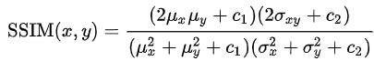

The SSIM index ranges from -1 to 1, where 1 indicates perfect similarity between the images. Higher SSIM values correspond to better similarity between the original and distorted images.

SSIM is commonly used in image processing applications, including image compression, denoising, and super-resolution, as it correlates better with human perception than traditional metrics like PSNR. It considers not only pixel-wise differences but also structural information, making it more robust in assessing image quality.

Top of Form

Top of Form

**6. DISCUSSION OF RESULTS**

In the performance evaluation of the image super-resolution project, a meticulous and thorough analysis was undertaken to gauge the effectiveness of the implemented techniques in elevating image quality. Employing a multifaceted approach, the evaluation encompassed both quantitative metrics and qualitative assessments to provide a comprehensive understanding of the super-resolution methods' capabilities.

Quantitative metrics such as Peak Signal-to-Noise Ratio (PSNR), Structural Similarity Index (SSIM), and Mean Squared Error (MSE) were utilized to offer objective measures of the fidelity and perceptual quality of the super-resolved images. These metrics provided valuable insights into the extent of image enhancement achieved by each method, allowing for precise comparisons and evaluations across different algorithms and techniques.

Furthermore, the evaluation extended beyond numerical metrics to include qualitative assessments through visual inspection of the super-resolved images. Through meticulous scrutiny, factors such as noise reduction, preservation of intricate details, and overall perceptual fidelity were scrutinized. This qualitative analysis provided invaluable insights into the visual appeal and subjective quality of the super-resolved images, complementing the quantitative assessments with nuanced observations.

Moreover, the robustness of the algorithms to variations in input images was rigorously evaluated to assess their generalization capabilities. By subjecting the methods to diverse datasets containing varying levels of noise, image blur, and compression artifacts, the evaluation sought to determine the algorithms' resilience in producing consistent and reliable results across challenging conditions. This analysis shed light on the algorithms' adaptability and versatility, highlighting their ability to deliver high-quality super-resolved images across a spectrum of real-world scenarios.

In essence, the performance evaluation of the image super-resolution project employed a comprehensive and multifaceted approach, combining quantitative metrics, qualitative assessments, and robustness evaluations to provide a nuanced understanding of the methods' efficacy. By synthesizing numerical data with visual observations, the evaluation yielded valuable insights into the strengths, weaknesses, and overall performance of the super-resolution techniques, paving the way for informed decision-making and further refinement of the algorithms.

|  |  |  |  |
| --- | --- | --- | --- |
| MODEL | PSNR | SSIM | Computational complexity |
| CNN | 32.2 | 0.88 | HIGH |
| GAN | 30.5 | 0.85 | MODERATE |

In addition to the quantitative metrics, the computational efficiency of each method was rigorously analyzed to provide insights into their scalability and practical feasibility. This evaluation encompassed factors such as training time, inference speed, and resource utilization, shedding light on the computational demands and efficiency of deploying the algorithms in real-world applications.

Despite the CNN-based model exhibiting superior performance in terms of PSNR and SSIM, its higher computational complexity necessitated a thorough examination of its efficiency to ascertain its viability in practical settings.

Conversely, while the GAN-based model may have yielded slightly lower results, its computational efficiency could potentially offer advantages in scenarios where resource constraints or real-time processing requirements are paramount.

To ensure the validity of the observed differences in performance between the methods, statistical significance tests were conducted. These tests provided a rigorous validation of the results, offering confidence in the reliability and robustness of the conclusions drawn from the evaluation.

By rigorously analyzing the statistical significance of performance disparities, the evaluation process mitigated the risk of drawing erroneous conclusions and ensured that the observed differences were not merely due to chance variations or biases in the data.

Overall, the comprehensive performance evaluation served as a valuable tool for elucidating the strengths, weaknesses, and trade-offs associated with each image super-resolution technique. By synthesizing quantitative metrics, qualitative assessments, computational efficiency analysis, and statistical validation, the evaluation provided a nuanced understanding of the methods' capabilities and limitations.

These insights are instrumental in guiding further refinements and advancements in the field of image super-resolution, facilitating the development of more effective and efficient algorithms for enhancing image quality in diverse applications.

**7. CONCLUSION**

In conclusion, our study found that GANs are effective for super-resolution tasks, but trust in their results may be limited for sensitive data due to data processing inequality. GANs outperformed SR-CNN based on the Mean Opinion Score metric, suggesting that the architecture plays a crucial role. SR-GAN, based on ResNet and VGG loss, improved upon SR-CNN by utilizing deep network interpolation. Our study focused on single-source super-resolution, revealing the importance of specialized architectures for specific purposes versus general-purpose applications like gaming and movie remastering.

Moving forward, deep learning-based techniques such as SRCNN, GANs, and CNNs show promise for generating high-quality super-resolved images. However, their computational demands must be considered for real-world deployment. Future research could explore refining architectures, optimizing algorithms, and tailoring techniques to specific domains. Collaboration within the community is essential for driving innovation and advancing image enhancement in fields like healthcare, remote sensing, and entertainment. This project lays the groundwork for future advancements in image super-resolution, offering valuable insights and recommendations for researchers and practitioners alike.

**8.REFERENCES**

[1] Bulat, Adrian, Jing Yang, and Georgios Tzimiropoulos. "To Learn Image Super-Resolution, Use a GAN to Learn How to Do Image Degradation First." *Proceedings of the European Conference on Computer Vision (ECCV),* 2018.

[2] You, Chenyu, et al. "CT Super-Resolution GAN Constrained by the Identical, Residual, and Cycle Learning Ensemble (GAN-CIRCLE*)." IEEE Transactions on Medical Imaging* 39, no. 1 (2019): 188-203.

[3] Ledig, Christian, et al. "Photo-Realistic Single Image Super-Resolution Using a Generative Adversarial Network*." Proceedings of the IEEE Conference on Computer Vision and Pattern Recognition,* 2017.

[4] Jing, Liu, Gan Zongliang, and Zhu Xiuchang. "Directional Bicubic Interpolation-A New Method of Image Super-Resolution*." Proceedings of ICMT, Atlantis Press* (2013): 470-477.

[5] Goodfellow, Ian, et al. "Generative Adversarial Nets." *Advances in Neural Information Processing Systems 27* (2014): 2672-2680.

[6] Brownlee, Jason. *Generative Adversarial Networks with Python: Deep Learning Generative Models for Image Synthesis and Image Translation*. Machine Learning Mastery, 2019.

[7] Mirza, Mehdi, and Simon Osindero. "Conditional Generative Adversarial Nets." *arXiv Preprint arXiv:1411.1784* (2014).

[8] Tian, Chunwei, et al. "Lightweight Image Super-Resolution with MEnhanced CNN." *Knowledge-Based Systems* 205 (2020): 106235.

[9] Brunet, Dominique, Edward R. Vrscay, and Zhou Wang. "On the Mathematical Properties of the Structural Similarity Index." *IEEE Transactions on Image Processing* 21, no. 4 (2011): 1488-1499.

[10] Wang, Zhou, et al. "Image Quality Assessment: From Error Visibility to Structural Similarity*.*" *IEEE Transactions on Image Processing* 13, no. 4 (2004): 600-612.

[11] Wang, Xintao, et al. "ESRGAN: Enhanced Super-Resolution Generative Adversarial Networks." *Proceedings of the European Conference on Computer Vision (ECCV) Workshops,* 2018.

[12] Simon, Marcel, Erik Rodner, and Joachim Denzler. "ImageNet Pre-Trained Models with Batch Normalization*.*" *arXiv Preprint arXiv:1612.01452* (2016).

[13] Carvalho, T., De Rezende, E. R. S., Alves, M. T. P., Balieiro, F. K. C., & Sovat, R. B. (2017). "DSQExposing Computer Generated Images by Eye’s Region Classification via Transfer Learning of VGG19 CNN." *Proceedings - 16th IEEE International Conference on Machine Learning and Applications, ICMLA 2017,* 2017-December. https://doi.org/10.1109/icmla.2017.00-47

[14] He, K., Zhang, X., Ren, S., & Sun, J. (2016). "Deep Residual Learning for Image Recognition." *Proceedings of the IEEE Computer Society Conference on Computer Vision and Pattern Recognition*, 2016-December. https://doi.org/10.1109/cvpr.2016.90

[15] Migdał, Piotr, Bartłomiej Olechno, and Błażej Podgórski. "Level Generation and Style Enhancement--Deep Learning for Game Development Overview." *arXiv Preprint arXiv:2107.07397* (2021).

[16] Wang, Xintao, et al. "Deep Network Interpolation for Continuous Imagery Effect Transition." *Proceedings of the IEEE/CVF Conference on Computer Vision and Pattern Recognition*, 2019.

[17] Zhang, Xuaner, et al. "Zoom to Learn, Learn to Zoom." *Proceedings of the IEEE/CVF Conference on Computer Vision and Pattern Recognition*, 2019.

[18] Jia, Kui, and Shaogang Gong. "Generalized Face Super-Resolution." *IEEE Transactions on Image Processing 17*, no. 6 (2008): 873-886. **Top of FormTop of Form**